

SCHOOL *of* BUSINESS AND TECHNOLOGY

Department of Engineering and Aviation Sciences

**Design of Oyster Activity Detection System**

**Shanice Nurse**

**Ashley Afueh**

Advisor: Dr. Zhang

October 28, 2020

Oyster Activity Detection System

By

Shanice Nurse & Ashley Afueh

Submitted to the Department of Engineering and Aviation Sciences in partial fulfillment of the requirements for the degree of Bachelor of Science in Engineering at the

UNIVERSITY OF MARYLAND EASTERN SHORE

Date

The author hereby grants the University of Maryland Eastern Shore permission to reproduce and distribute publicly, paper and or electronic copies of this document in whole or in parts.

Authors Shanice Nurse, Ashley Afueh

Signature

Date

Department of Engineering and Aviation Sciences

Certified by

**List of Contents**

Abstract 3

Introduction 4

1.1 Background/Motivation 4

1.2 Objective 6

1.3 Design Requirements 6

1.4 Design Constraints 6

1.5 Design Method 6

1. Project Description 8

2.1 System Description 8

2.2 System Diagram (or Flow Chart) 8

2.3 System Functions 8

3. Implementation Plan 9

3.1 - Tasks 9

3.2: Team Organization 10

3.2.1: Responsibility of Team Member 1: 10

3.2.2: Responsibility of Team Member 2: 10

4. Implementation 12

Task 1: Design software for practice image identification 12

Subtask 1.1: 12

Subtask 1.2: 12

Task 2: Design Image Processing System Using Neural Network to Identify Activity Level 13

Subtask 2.1: Data Collection 13

Subtask 2.2: Preprocessing Data 14

Subtask 2.3: Normalize the Dataset​ 15

Subtask 2.4: Adding Layers & Nodes 15

Subtask 2.5: Breakdown of Neural Network – Feature Extraction 17

Subtask 2.6 - Training the network 18

Subtask 2.7 - Testing the Network​ 19

Subtask 2.8: Establish Additional Details to Finalize System 20

Task 3: Test, Evaluate, and Refine System 20

Subtask 3.1: Testing System 21

Subtask 3.2: Evaluating the System 21

Subtask 3.3: Refining the System 21

Task 4: Design Website that Displays results of system 21

Subtask 4.1: Data for Openings 22

Subtask 4.2: Data for Closings 23

Subtask 4.3: Numerical/Visual Archived Data 23

Subtask 4.4: Contact Information 24

5. Project evaluation 25

6. Conclusion 26

Acknowledgment 27

Appendix 28

1. Tutorial for How to Run System: 28

2. Source Code from Google Cloud Function 37

3. Source Code for Google Collab Function 41

REFERENCES 50

**List of Figures**

Figure 1. Mussel Active Filtering (A), Voltage Output(B), Mussel Resting(C). 6

Figure 2. Design Method. 8

Figure 3. System Flow Chart 9

Figure A: Depiction of Glued Oysters 13

Figure B: Depiction of Jupyter Notebook 14

Figure C – Depiction of Different Types of Positions of Oysters in the Testing and Training Folder 15

Figure D: Image Being Processed 16

Figure E: Example of Dataset Being Normalized’ 16

Figure F: Depiction of Convolutional Neural Network 18

Figure G: Depiction of Flattening an Image and how CNN works 18

Figure H: Example of feature extraction 19

Figure I – Depiction of Network Being Trained 20

Figure J: Image of Network being Tested 21

Figure K: Evaluations of System 22

Figure L: Depiction of Design of Website 23

Figure M: Depiction of Tab for Data for Openings 24

Figure N: Depiction of Tab for Data for Closings 24

Figure O: Numerical and Visual Archived Data 25

Figure P: Tab for Contact Information 25

References (Extended) 51

## Abstract

Due to oyster cultivation oysters are able to naturally grow when in a farmed environment when the temperature and sanity of the water are controlled. In order to induce growth, and rate of maturation which could take several years. In this paper, we apply a convolutional neural network (CNN) to the task of detecting oysters and recognizing the activity of each individual oyster. Because there is a wide diversity of sea creatures with different features, image recognition of sea creatures is generally very difficult. However, deep learning has been shown recently to be a very powerful image recognition technique to monitor different patterns and behaviors. The convolutional neural network is designed to detect the oyster’s activity; the oysters are in two states, either active or rest through parameter optimization. A dataset of numerous images of individual oysters was constructed both active and resting in a publicly accessible cloud storage system and used it to evaluate recognition performance. CNN showed significantly higher accuracy than did traditional support-vector-machine-based methods with handcrafted features. In addition, we found that convolution kernels show that color dominates the feature extraction process. For oyster activity mage detection, CNN also showed significantly higher accuracy than a conventional method did.

## Introduction

### 1.1 Background/Motivation

Oysters provide a positive environment for the coastal and estuarine waters. Shellfish cultivating can give communities an assortment of environmental benefits, whose worth can be quantified. oysters have the ability to clean the water which they’ve grown in by filter feeding. By this way of feeding, oysters filter phytoplankton, microorganisms, and detritus. By filtration, oysters improve water quality by diminishing sediment loads and turbidity and expelling abundance supplements from inshore coastal waters. Clear water quality permits more daylight to infiltrate, which helps in the development of significant seagrasses and expands oxygen.

The capability of remotely monitoring the behavior of oysters and their relationship with their habitat has restructured how ecologists conduct research. Shellfish cultivating can give nearby communities an assortment of environmental benefits, whose worth can be quantified. Freshwater mussels (Unionoida) are target species in aquatic conservation and belong to one of the fastest diminishing taxa globally (Bogan, 1993; Geist, 2010, 2015). Most recently, there has been a critical effort to put resources into improving the conception of the reasons for the decrease of Unionoida. Biologists have urged the discovery of a solution to observe the behavior, physiology, and ecological conditions experienced by creatures as they progress and communicate with their habitat. On account of the mechanical advances made in the course of the most recent 40 years, a wide range of approaches have been created to precisely comprehend the lives of creatures that go overlooked by the observation of an ecologist. Comprehensively, the strategies used to monitor oysters are directly related to the "biotelemetry", which can be characterized as the remote detection of physiological, or behavioral activity information. It is effective to include biotelemetry into the study of oysters in order to have a precise understanding of its preservation to the ecosystem. The standard amount of biotelemetry incorporated in research, differs enormously, from the utilization of data recorded, to transmitters that send data to either land-based receivers, or to a satellite circumnavigating the earth. For this reason, researchers and different articles suggest it useful to attach sensors to the mussels’ shell for ecological investigations and preservation ventures.

Various research projects range from, but are not limited to, mark-recapture studies to translocation and restocking programs, and mussel behavior research (Smith, Villella & Lemarié, 2003; Villella, Smith & Lemarié, 2004; Kurth *et al.*, 2007; Wilson *et al.*, 2011; Hartmann *et al.*, 2015). For instance, the controlled release of captive-reared freshwater pearl mussels (*Margaritifera margaritifera*) requires effective tools to monitor the success of such conservation projects (Gum, Lange & Geist, 2011). Adjoining sensors to a mussel may bring about strain for the mussel and increase endangerment to their vulnerability to harmful mixes from the glue. To connect an item includes the expulsion of the mussel from its condition, cleaning and drying the shell, applying the paste, squeezing the remote article against the shell and, for some paste', the procedure additionally includes keeping the mussel out of the water until the paste is dry. Currently, there are experimental studies of filtration-behavior and biological rhythm for freshwater mussels. Biologists perform their research by attaching objects to bivalve shells for conservation projects, mark-recapture studies, and behavioral analysis. The “marking” process is performed by using a magnet and a rubber-coated Hall sensor glued with cyanoacrylate adhesive attached to a mussel shell known as the “Anodontia Anatina.” These attachments were built to last for nine months after attachment. This system was designed for a filtration-behavior experiment, which identified a circadian rhythm. This experiment was performed by placing twenty-six mussels that were randomly selected were placed into two different closed recirculating aquarium systems. After allowing the mussels to adapt to their laboratory habitat for about 12 days, a Honeywell SS495A linear position Hall sensor (Honeywell, USA) and magnet were then attached for monitoring behavior. Additionally, this system allowed ecologists to observe the water quality parameters, dissolved oxygen (DO), pH and EC daily. Figure 1 depicts the measurement of a mussel’s filtration behavior using the change in proximity of a magnet (in right valve) to a Hall sensor (on left valve). In Figure 1, photograph B depicts a graph showing a measurement of the voltage output transduced by the Hall sensor when the mussel is active and resting.

Figure 1.

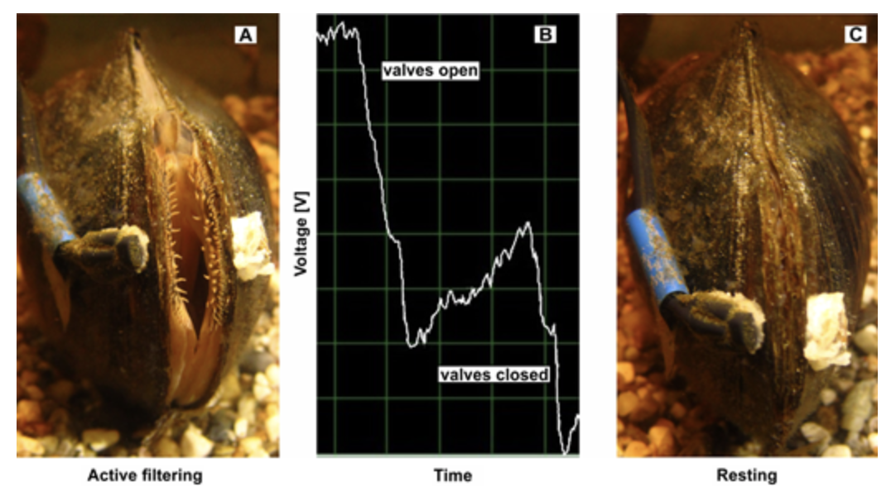

# Figure 1. Mussel Active Filtering (A), Voltage Output(B), Mussel Resting(C).

This project is intended to assist in research for the Food & Science Department at the University of Maryland Eastern Shore. By developing a oyster Activity Detection System, a dataset from the activity of the oysters will be derived from the activity observed without putting addition strain on the oysters. This would be extremely beneficial to ecologist and researchers as they can remotely monitor precise data from their experiments. The dataset will be the basis for the development, evaluation, and use of the neural network developed. During this project, there will be models developed for photograph classification, and object detection to further investigate the activity of oysters. By creating this development, the department will have a better insight of the oysters’ behavioral activity with its environment. The Deep learning Convolutional Neural Network will be trained with an image classification model to observe each oyster individually. This neural network is intended to monitor the oysters’ amount of interaction, length of interaction, growth, and its overall adaptivity to its surroundings. This deep learning model will have the ability to integrate the feature extraction and classification process into a whole to record when the oyster is most comfortable.

The purpose of this project is to develop a SMART system that will precisely monitor the activity and interaction of oysters without the tedious strain imposed on their shell. By using deep learning approach to monitor the oyster’s activity the data will be recorded with increased accuracy. As previously stated, there methods on the market that will accomplish similar tasks as our system. However, the methods do not offer the precision and comfortability our system can guarantee.

### 1.2 Objective

The objective of this project is to design a program applying deep learning neural networks to monitor oyster activity level and create a website that displays data from the oyster activity level.

### 1.3 Design Requirements

The design requirements for this project are as follows:

1. Create program using a deep learning neural network to monitor activity levels for oysters

2. Create a website for data analysis of oyster activity.

### 1.4 Design Constraints

This project has the following design constraints: ​

- There is only a $200 budget that we can afford. This limits the type of materials we can use and the type of software we can use for the project. While we have a functioning project, it would be able to function much more effectively if we had a higher budget. ​

- Since the program takes pictures based on image, the tank must have light inside of it to be able capture a good image. If there is no light available to the tank, then the system will not work because it needs like to take a good picture to process the image. ​

-If an air pump is added to the tank, the quality of the image may be affected. Since the image is being taken from the top of the tank, the picture needs to have still water so it can see the image through the tank. If the water has an air pump attached to it, then the water will not be still and the quality of the picture will be affected. So, if there is an air pump, an underwater waterproof camera might be needed. This camera is out of our budget. ​

### 1.5 Design Method

The first step in creating the project is to set up the lab. The second step is to create an image processing program with a deep learning neural network. ​The third step is to test and evaluate the program. The fourth step is to make improvements to the program if necessary and then finalize it. And the fifth step is to create the website that features all data from the program available on it. ​

# Figure 2. Design Method.

## Project Description

### 2.1 System Description

## First, the camera takes pictures of the oyster shells, and forwards this picture to the raspberry pi. Then, the raspberry pi processes the image, and the results of this image being processed goes to a cloud storage service. After the raspberry pi communicates to the cloud, the cloud will have data extracted from the image that was processed. It will store this data here in the cloud. The website will get its data from here in order to visualize the data from the program for the users to view. ​

### 2.2 System Diagram (or Flow Chart)

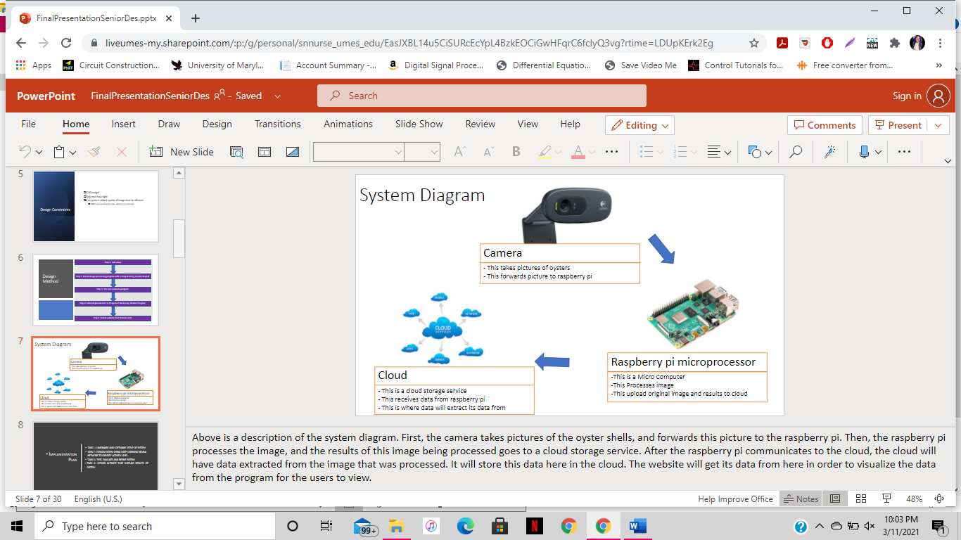

# Figure 3. System Flow Chart

### 2.3 System Functions

This system uses a camera which will monitor the oyster’s various activity; either resting or active. This information is then communicated to the Raspberry Pi. In the microcomputer, there is a system design which utilizes Artificial Intelligence and a Convolution Neural Network to process the data extracted from the images recorded. The data is then transmitted to a local network for visual recordings.

## 3. Implementation Plan

### 3.1 - Tasks

All tasks are defined as the following:

* Task 1: Hardware and Software Setup of System
  + Subtask 1.1: Hardware Implementation of Lab Setup
  + -Subtask 1.2: Software implementation of lab setup​
* Task 2: Design Image Processing System Using Neural Networks to Identify Activity Level ​
* Subtask 2.1: Data Collection
* Subtask 2.2: Preprocessing Data
* Subtask 2.3: Normalize the Dataset
* Subtask 2.4: Adding Layers & Nodes
* Subtask 2.5: Breakdown of Neural Network – Feature Extraction
* Subtask 2.6: Training the network
* Subtask 2.7: Testing the Network​
* Subtask 2.8: Establish additional details to finalize system
* Task 3:  Test, Evaluate, and Refine System
* Subtask 3.1: Test System
* Subtask 3.2: Evaluate System
* Subtask 3.3: Refine System

* Task 4: Design Website that Displays Results of System
* Subtask 4.1: Create Page for Data for Openings
* Subtask 4.2: Create Page for Data for Closings
* Subtask 4.3: Create Page for Numerical/Visual Archived Data
* Subtask 4.4: Create Page for Contact information​

### 3.2: Team Organization

Team Member 1: Shanice Nurse

Team Member 2: Ashley Afueh

### 3.2.1: Responsibility of Team Member 1:

* Task 1: Hardware and Software Setup of system ​(50%)
* Task 2: Design System Using Deep Learning Neural Network to Identify Activity Level ​(50%)
* Task 3: Test, Evaluate and Refine system​ (50%)
* Task 4: Design Website that Displays results of system ​(50%)

### 3.2.2: Responsibility of Team Member 2:

* Task 1: Hardware and Software Setup of system ​(50%)
* Task 2: Design System Using Deep Learning Neural Network to Identify Activity Level ​(50%)
* Task 3: Test, Evaluate and Refine system​ (50%)
* Task 4: Design Website that Displays results of system ​(50%)

1. **Project Timeline and Delivery Plan**

|  |  |  |  |
| --- | --- | --- | --- |
| Time | Task | Responsibility Personnel for Ashley Afueh | Responsibility Personnel for Shanice Nurse |
| Week 1 | Task 1 | 1.1 | 1.1 |
| Week 2 | 1.2 | 1.2 |
| Week 3 | Task 2 | 2.1 | 2.2 |
| Week 4 |
| Week 5 | 2.3  2.3 | 2.4 |
| Week 6 |
| Week 7 | 2.5 |
| Week 8 | 2.6 |
| Week 9 | 2.7 |
| Week 10 |
| Week 11 | Task 3 | 3.1 | 3.1 |
| Week 12 |
| Week 13 |
| Week 14 | 3.2 | 3.2 |
| Week 15 |
| Week 16 | 3.3 | 3.3 |
| Week 17 | Task 4 | 4.1 | 4.2 |
| Week 18 |
| Week 19 |
| Week 20 | 4.3 | 4.4 |
| Week 21 |
| Week 22 | 4.5 | 4.5 |

## 4. Implementation

### Task 1: Design software for practice image identification

For the first task, the hardware and software setup for the system was done.

### Subtask 1.1:

In this task, the shells were glued together in various different positions using a glue gun. These positions represented how the oysters were positioned in real life. The oysters had 3 positions, which were completely closed that was open by 0cm, slightly opened, which had a shell opening of 0.5cm, and largely open, which had a shell opening of 1cm. Once the oysters were completely glued, they were put in the tank. ​This task can be illustrated in Figure A below.

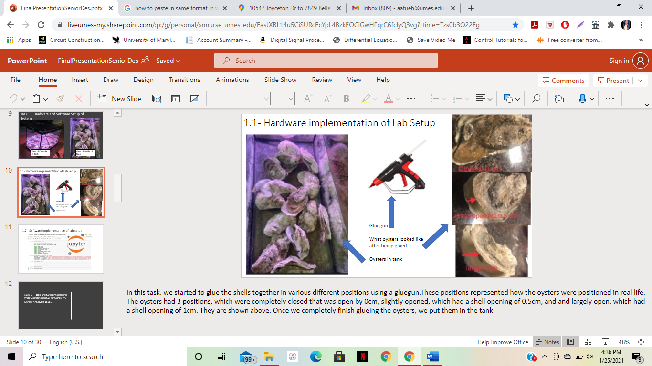

# Figure A: Depiction of Glued Oysters

### Subtask 1.2:

Here, in this step, the software for the project was set up. This software is on an online coding web application called Jupyter notebook. Jupyter notebook is an open-source web application that can be used to create and run coding programs online. This notebook is what will be used for this program. The coding language that was used is python. ​The following figure, Figure B, is a depiction of a Jupyter notebook.

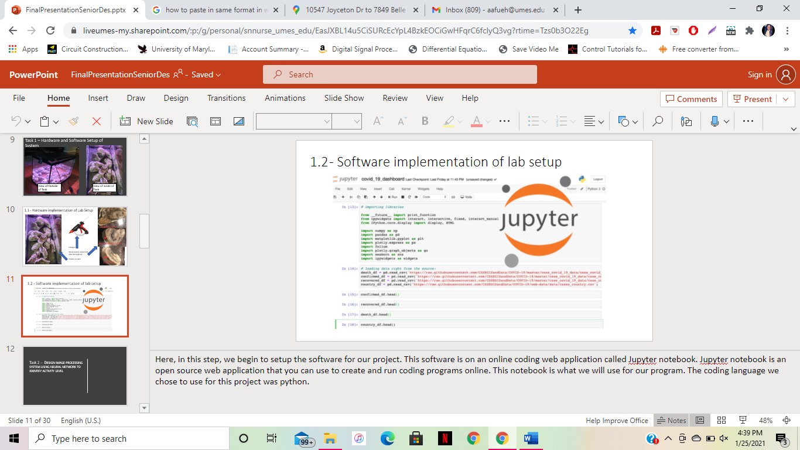

# Figure B: Depiction of Jupyter Notebook

### Task 2: Design Image Processing System Using Neural Network to Identify Activity Level

In order to have the program identify the oyster shell's position while they are in the tank, an image processing program was created. An image processing program is a computer science program where the operations are performed on an image, in order to extract some useful information from it. The input is an image and output may be image or characteristics/features associated with that image. In this case, the input was the pictures taken with the camera and the output was the classification of the position of these oysters. ​

### Subtask 2.1: Data Collection

In order to process this image, two folders full of images were created. The first folder is the training folder and the second folder is the testing folder. The training folder has 3 folders in it – a folder of slightly opened oyster shells, a folder of largely opened oyster shells, and a folder of closed oyster shells. Each folder has 264 images in it. The folder within images was inputted into a code via python, which is a programming language. The testing folder has 200 images in it. The images contain pictures of the entire tank full of oyster shells in various positions. The program was then trained to identify these 3 different categories of images in the training folder and then this training was used to test how well the images in the testing folder can be identified. ​The following figure, Figure C, depicts the different type of oyster positions within the various folders.

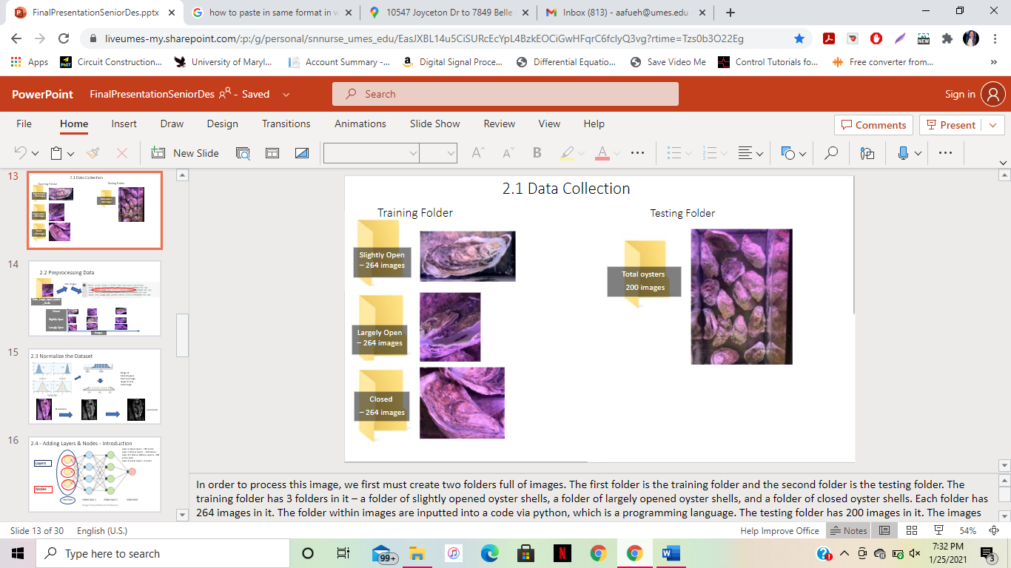

# Figure C – Depiction of Different Types of Positions of Oysters in the Testing and Training Folder

### Subtask 2.2: Preprocessing Data

The dataset first was imported into the Jupyter notebook. When the images are imported, they are imported in a 28x28 image. These images have 3 classes, slightly open, largely open, or closed. When the folder was uploaded into the Jupyter notebook, the pictures in the folder are uploaded into an x and y axis similar to what is shown above. The x axis has the images and the y axis has the labels. ​The following figure, Figure D, depicts the image being preprocessed.

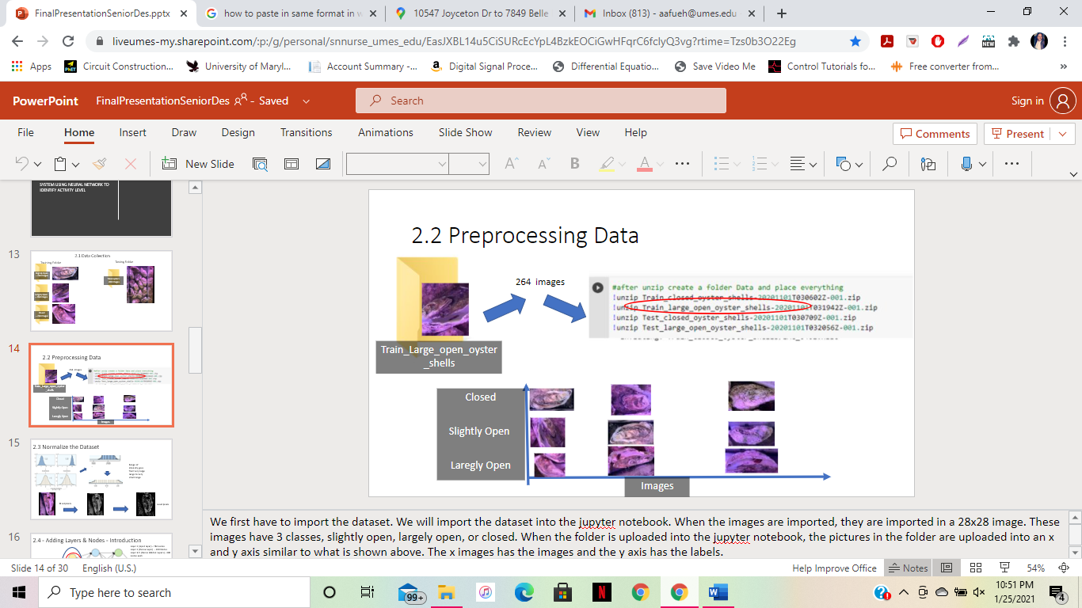

# Figure D: Image Being Processed

### Subtask 2.3: Normalize the Dataset​

In this subtask, the dataset is normalized. This is a process that changes the range of pixel intensity values from a large range of values into a more familiar range of values that are more comfortable to work with. In this case, the images will be turned into a greyscale image to normalize the image. This is helpful because it helps all the images to become in a familiar pixel intensity range for us to work with for the training. When all the images go from a colored image to a greyscale image, the image's pixels then transform from a range of different colors of red, green, and blue, to just one range of gray. While there are different shades of grey, there is only one type of various shades, or one type of intensity value, which would be the intensity values of gray. This is much easier than dealing with the three different intensity values of red, green, and blue. If all images are normalized to a greyscale image, then it creates an easier way for the training model to become familiar with the pictures. ​The following figure, Figure E, depicts an example of the dataset being normalized.

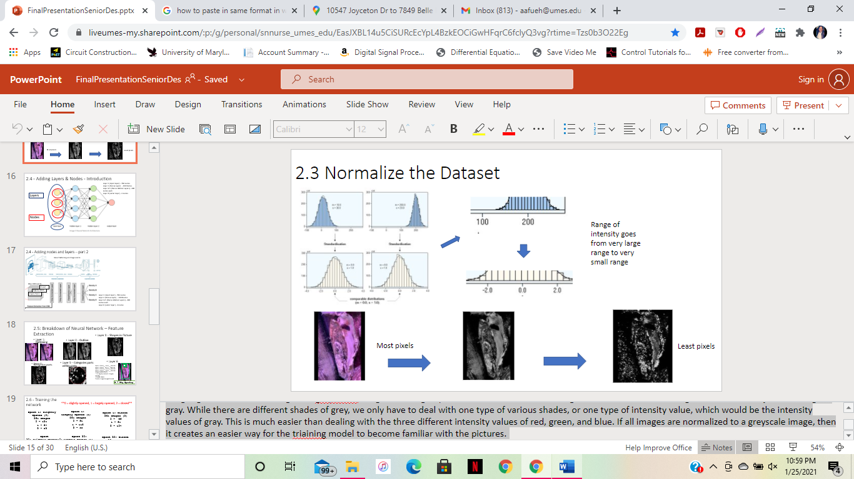

# Figure E: Example of Dataset Being Normalized’

### Subtask 2.4: Adding Layers & Nodes

To build this image processing program, a neural network was built. A neural network is a system of units designed to compute an output through a mathematical process. ​

​

There are 3 different types of neural networks which are as follows: An Artificial Neural Network, or ANN, a Recurrent Neural Network, or RNN, and a Convolutional Neural Network, or CNN. An ANN is a group of multiple neurons at each layer. An RNN has a recurrent connection on the hidden state. A CNN is used to extract the relevant features from the input using the convolution operation. CNN's grasp the importance of filters using images as input data. Convolving an image with filters results in a feature map which help to extract data from these features and make predictions about an image. Since they are useful for image and video processing projects, a convolutional neural network will be used for this project. ​

 ​

Cnns consist of layers, circled in blue in Figure F, and these layers consist of nodes, circled in red in Figure F. Each node is connected with each node from the next layer and each connection, which is the black arrow has a particular numerical numbered weight. Weight can be seen as impact that that node has on the node from the next layer. The data from these nodes were put in a vector and calculated to give us an output of a specific number. This number was able to represent data. ​

​

Within this convolutional neural network, a system of layers was created and those layers consist of nodes. These nodes are what the image passes through to become identifiable. A node is a computational unit that has one or more weighted input connections, a transfer function that combines the inputs, and an output connection. Nodes were then organized into layers to create a network. ​

​

The first layer is called an input layer. The next layers, excluding the last layer, consist of hidden layers. Hidden layers are intermediate layer between input and output layer and place where all the computation is done. The last layer is called an output layer. The output layer produces the result for given inputs. ​The following figure, Figure F, depicts what the convolutional neural network looks like.

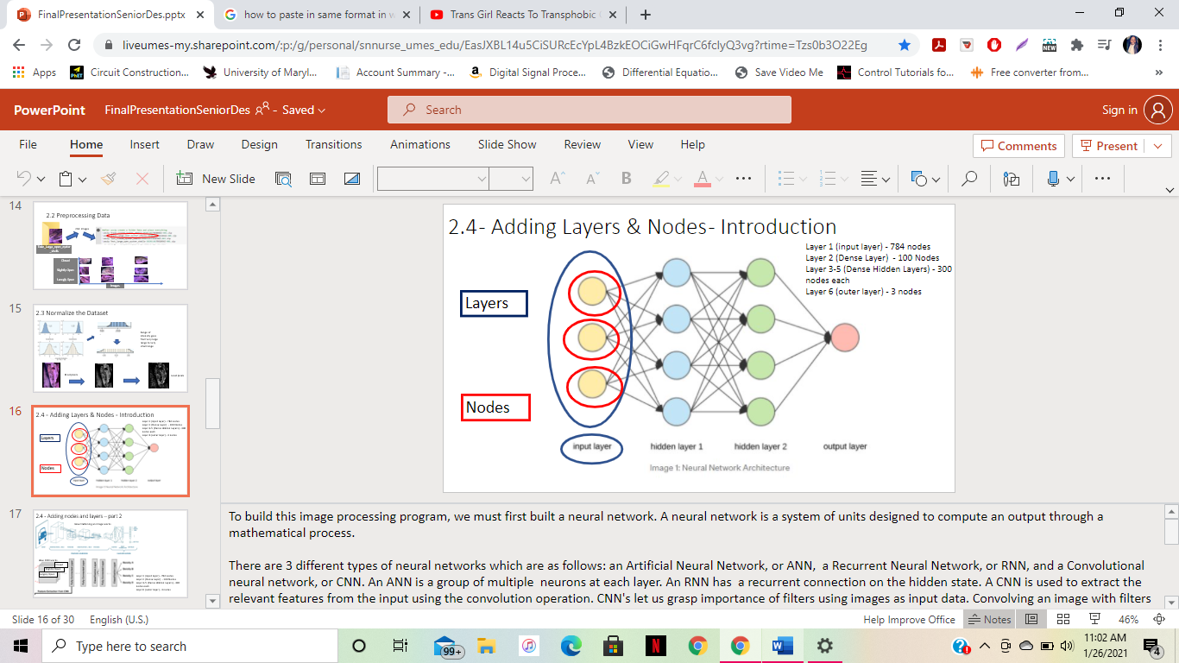

# Figure F: Depiction of Convolutional Neural Network

For the convolutional neural network, a process called feature extraction was done. ​

The neural network was fed 3 different classes of information, which are the 3 different categories in the training folder. This includes the largely open data set, the slightly open data set, and the closed data set. ​

There are various different layers in the neural network. Each layer as having a particular purpose. Each different layer is looking for a different feature in order to identify the position of the shell. Within these layers, there are nodes that the image is passing through. These nodes within the layer categorize which feature was found in the layer. For example, if there is a layer looking for a feature that has 5 different possible characteristics, numbered 1-5, then the node 1 will be characteristic 1, node 2 will be characteristic 2, so on and so forth. ​The following Figure, Figure G, depicts how flattening an image works and how a CNN works.

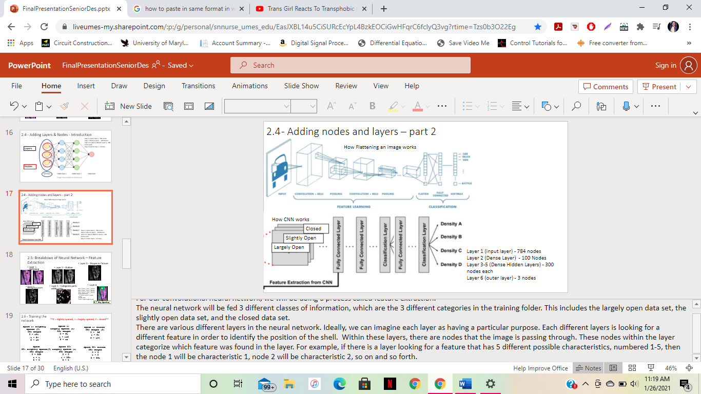

# Figure G: Depiction of Flattening an Image and how CNN works

### Subtask 2.5: Breakdown of Neural Network – Feature Extraction

​

The first layer in the model is the flatten layer and it preprocessed the dataset once again. The first layer flattens the image from a 2-dimensional picture to a 1-dimensional picture so the picture can be in a format that is readable to the neural network. The data needed to be transformed into a format that it can extract information from to interpret things. This layer flattened the images from a 28x28 array to a 1x784 array. This layer has 784 nodes in order to accommodate the pictures passing through the neural network that has 784 pixels. ​

​

Next, a Dense hidden layer was added with 300 neurons. This hidden layer recognized the outline of the shell. Each Dense layer managed its own weight matrix, containing all the connection weights between the neurons and their inputs. This layer is important because when the data ran through this layer, it analyzed the features and made a guess about how to identify this data given this feature. The nodes in this layer generated a specific number that represented a guess to what category the picture in the dataset belongs to. This number is in response to the mathematical process occurring during a CNN. ​

​

Next, another 3 Dense layers with 100 neurons each were added. 3 layers were added because 3 more features are being looked for, and 100 nodes in each layer were added because there are 100 different categories within each feature in the layer. These layers continued to recognize different features in the picture. One layer recognized certain shapes within the pixels of the picture that are familiar with a specific type of position. One layer recognized oyster shell parts within that shape. For example, a circle within a circle may be familiar to the length of a shell opening or a shell closing.  There are diminishing returns to adding new layers and this is something that needed to be tested as the network is being built. As the data passes through these layers, it tries to narrow down the guessing of the pictures in the dataset. ​

​

Finally, Dense layer with 3 neurons was added since there are 3 classes to predict. The last layer recognized what type of position the oyster shell it is based on the characteristics found in previous networks. ​

The following figure, Figure H, depicts feature extraction taking place.

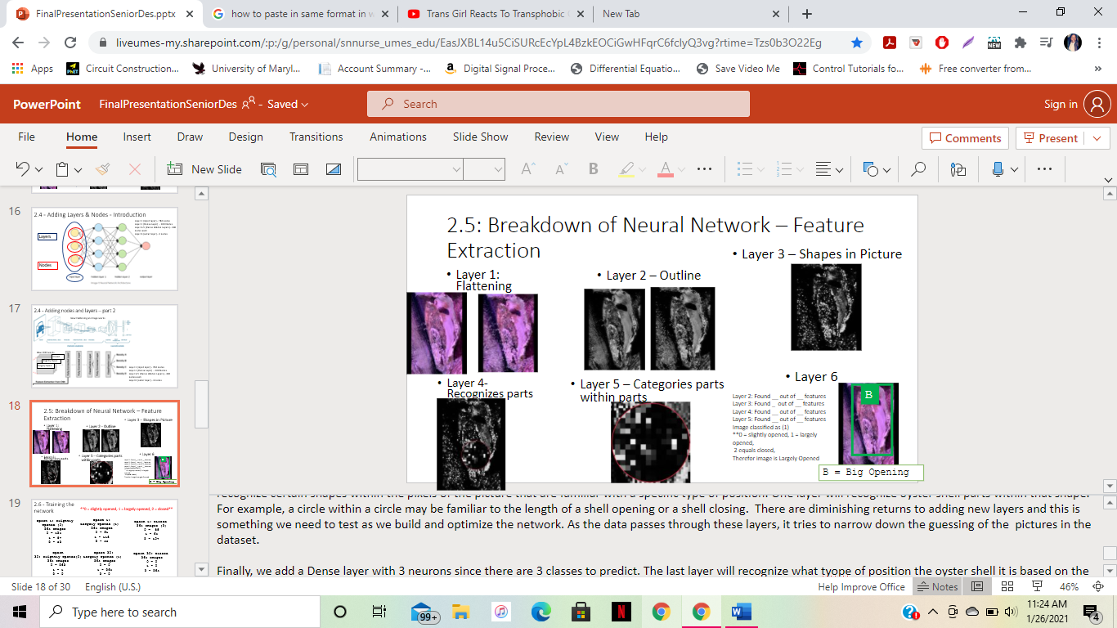

# Figure H: Example of feature extraction

### Subtask 2.6 - Training the network

The model was trained in this subtask. The number of epochs was specified first, which is 30 in this case. An epoch is defined as how many times the training data through the network for training purposes. It was trained with 30 different trials. The model was given 264 images in a folder. Each folder has 1 category of oyster positions. The positions of oysters are given a numerical label. Slightly opened was given the number "0", largely opened was given the number "1", and closed was given the number "2". Every time the model runs, 264 images that all are in the same category of positions will be fed to the model. The model told us within those images, how many pictures it identified for each category. The goal is, for when the training is over, to have the model identify all 264 images in 1 category, which is supposed to match the category that was given to the model. ​

​

As shown in Figure I, during the first epoch for all 3 categories, the model severely inaccurately identified the positions of the oysters. The model inaccurately identified many of the pictures that were fed to it. It is supposed to have all 264 images in 1 category, but in the first epoch, for all categories, it identified the pictures in various categories. ​

​

However, during the end of the training, the model greatly improved. It accurately identified the pictures of the oysters fed to it. It categorized all images in 1 category as it should, with the exception of the slightly opened category, which only inaccurately identified 1 picture. Nonetheless, the model still now has a great accuracy percentage of 99.75%. ​The following figure, Figure I, shows a depiction of the network being trained.

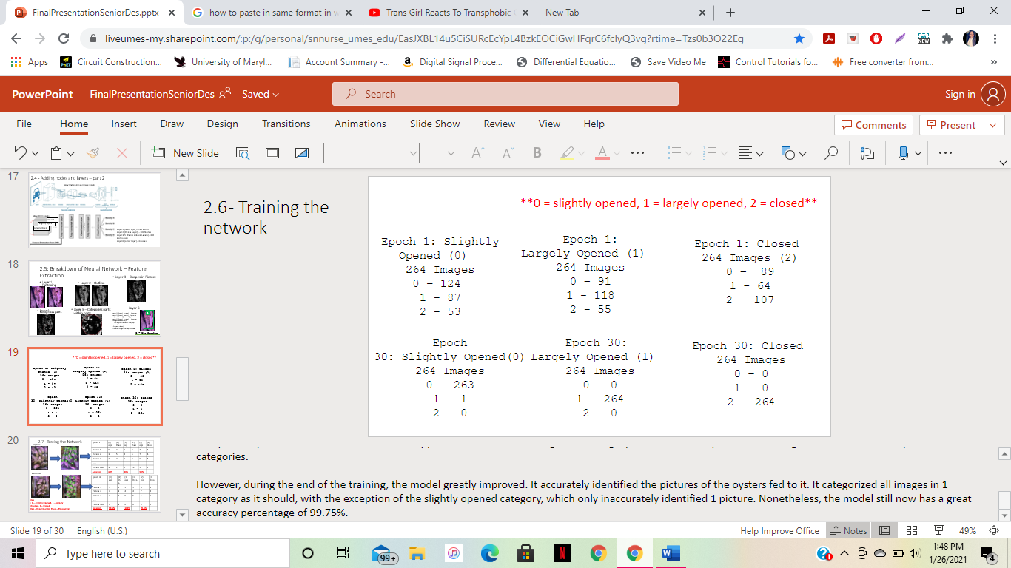

# Figure I – Depiction of Network Being Trained

### Subtask 2.7 - Testing the Network​

When the model was done training, it was tested on how well the model works with the testing dataset. The model was tested on how well it can identify the positions of oysters within an image of different oysters with different positions. ​

The model was fed with 200 different images. Each image contains a tank full of oysters in different positions. The model will tell us how many large opened shells, small opened shells, and closed shells there are in the image. In addition to giving us numerical data of how many different positions it found, it will also give visual data of the oysters it labeled within each picture. ​

​

There is a list of the real number of different positions within each picture for all 200 of the testing images. This list will be compared to the experimental list that the model gives us and see how many times the model inaccurately measured the oysters position. There will be 30 epochs for the testing model. Once the model was done training, there was an accuracy percentage of 99.98%. ​The following figure, Figure J, depicts the model being tested and the results for it.

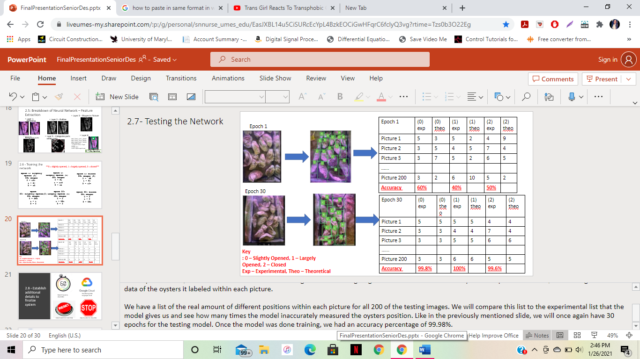

# Figure J: Image of Network being Tested

### Subtask 2.8: Establish Additional Details to Finalize System

For the next task, the system was finalized. More parameters were added to the system. These parameters include changing the frequency of the picture being taken, ways to restart the system, ways to stop the system, transferring the data from the picture that is taken to a data cloud sharing service, which in turn allowed for the website data to be shared. This was simply done by extra coding via the python programming language in the Jupyter notebook. ​

### Task 3: Test, Evaluate, and Refine System

In this task, the system was tested, evaluated, and refined for finalization.

### Subtask 3.1: Testing System

The system ran in order to be tested. This task was very important in the project because it found any errors in our system in order to fix. After finding the best lighting position for the oysters in order to take clear pictures, and fixing any errors the Jupyter notebook, the program was tested. The program ran for 5 hours, and the position of the oysters changed every 5 minutes. The camera took a picture every 1 minute.

### Subtask 3.2: Evaluating the System

The accuracy for the results for each hour is shown above. The system had a total result of 99.19%. This means that our program has an accuracy percentage of 99.19%. ​The following figure, Figure K, depicts the evaluation of the system.

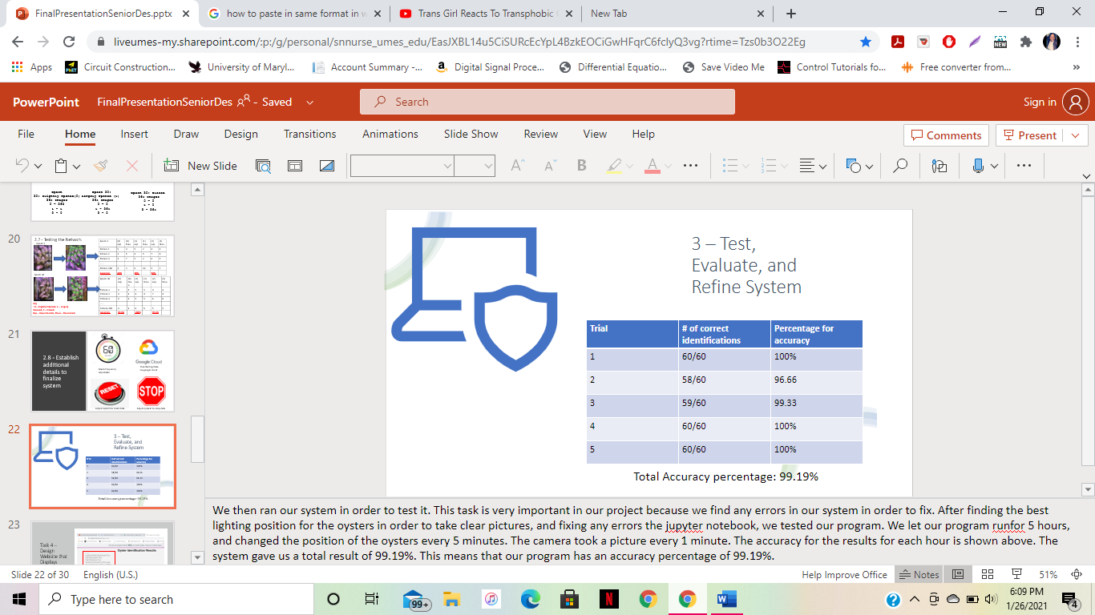

# Figure K: Evaluations of System

### Subtask 3.3: Refining the System

The system was refined and finalized in this step.

### Task 4: Design Website that Displays results of system

In this task, the website was generated using a free website database. This website obtains all the information regarding the oyster activity levels. They are displayed with hourly increments. This task is important because the user will have a way to visually view the data and extrapolate essential data needed from that data. This data will be embedded from a file from google sheets, which is a data source that was used with the project due to it being compatible with the code used for this project, and within the project’s cost range. ​The data will run as long as the user desires and can be stopped and reset by the user. There will be a viewing for large and small openings per hour, total openings per hour, total closing per hour, archives, and contact information for help. ​The following figure, Figure L, is a depiction of what the website is designed.

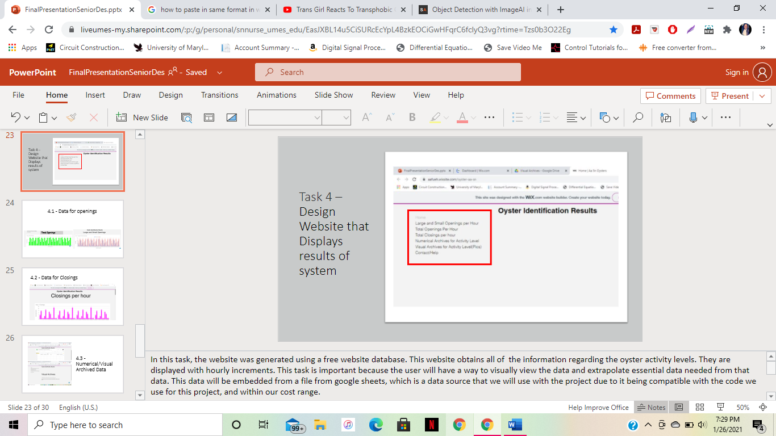

# Figure L: Depiction of Design of Website

### Subtask 4.1: Data for Openings

The number of opened oysters per hour can be viewed in 2 ways – total openings overall or small and large openings. If the user would like to see the entire number of openings, they can do that in the third tab, where the entire openings per hour will be shown. There will 1 bar graph for each hour. If the user wanted to see how many were small openings and how many were large openings throughout the time, they can go to the second tab, where the large and small openings are differentiated. ​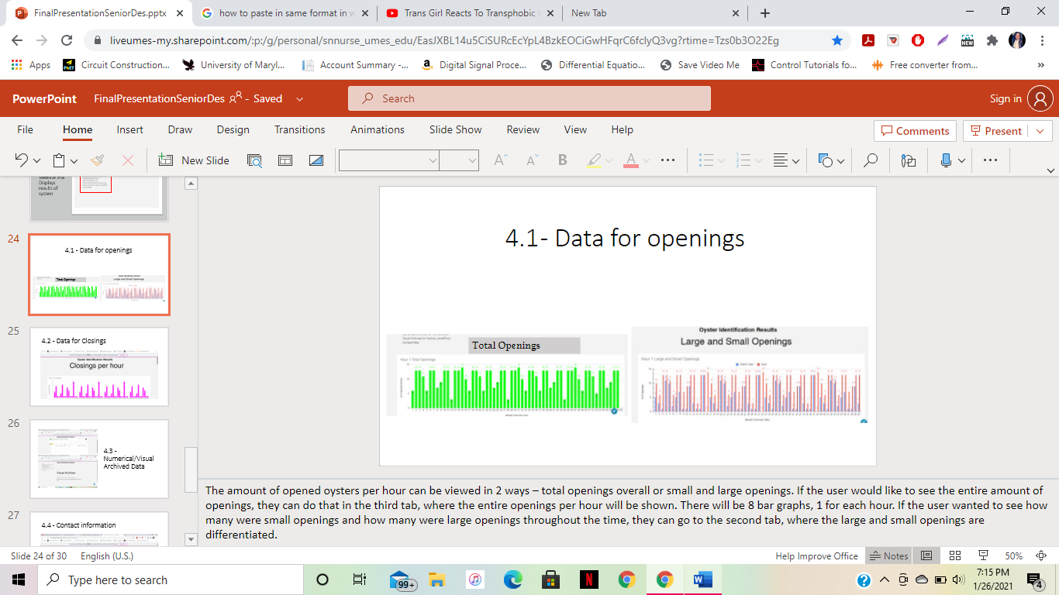

# Figure M: Depiction of Tab for Data for Openings

### Subtask 4.2: Data for Closings

The number of closed oysters can be viewed in the fourth tab. This will tell the user the amount of closed oyster shells for every hour. There will be one bar graph for each hour. ​The following figure, Figure N, is a depiction of a tab for the data for the closings.

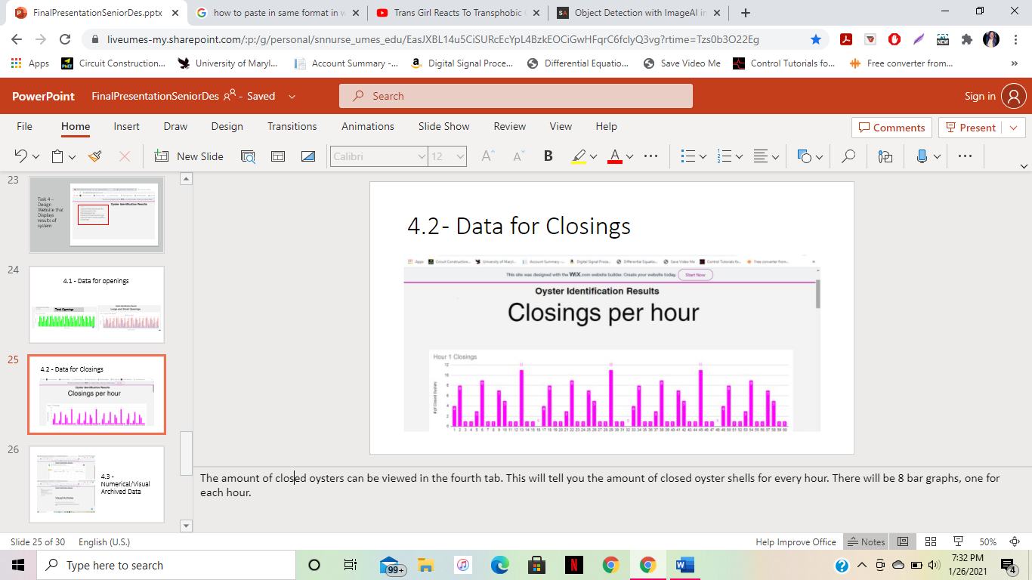

# Figure N: Depiction of Tab for Data for Closings

### Subtask 4.3: Numerical/Visual Archived Data

In this task, the tabs for the numerical and visual archived data were created. These two tabs depict the archived data from the system. The numerical data will be shown via a spreadsheet, it will have the numerical data for all hours starting as soon as the system starts. ​The visual data, AKA the labeled pictures that went through image processing, will be uploaded to this website for viewing. Every picture that is taken during the time the program starts will be viewable. ​

The following figure, Figure O, depicts the image of the numerical and visual archived data.

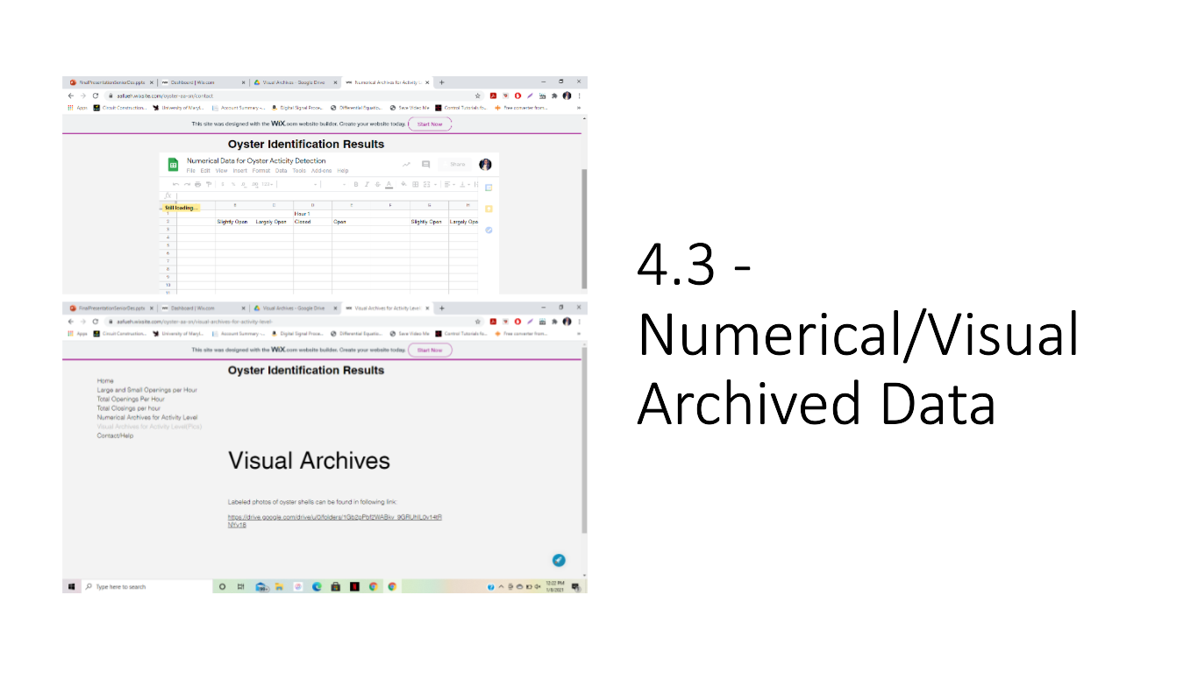

# Figure O: Numerical and Visual Archived Data

### Subtask 4.4: Contact Information

In this task, a tab for contact information was made. This is just in case the user is having difficulties and wishes to contact the creators of the program for any issues. The following figure, Figure P, depicts the tab for contact information.

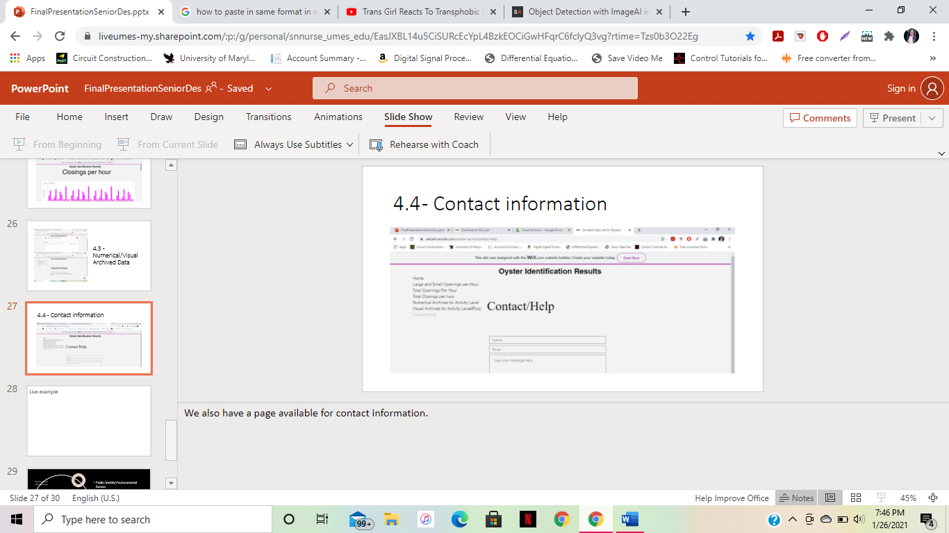

# Figure P: Tab for Contact Information

## 5. Project evaluation

1. Public health/Environmental factors

Monitoring oyster activity can assist greatly in helping to clean dirty and tarnished oceans across the globe. Since oysters have the ability to clean water, they have grown in my filter feeding, monitoring oyster activity can assist public health by determining the factors that they thrive best in. After determining these factors, this information can be utilized to move oysters to environments they thrive best in. In return, they will filter and clean the water around them, helping with clean water supply in the environment.

1. Safety/Welfare

In previous methods of oyster identification, many biologists and ecologists had to touch the oysters manually and check their shell openings manually. The method that was created in this project for oyster activity does not require consistent manual touching of the oysters, seeing as how their position will be determined by camera. Since there is minimal human contact with the oysters, this reduces the possibility of bacteria and/or other dangerous germs transferred from the oysters to humans. This program assists in safely tracking the opening of the oyster shells while still maintaining the welfare of the biologists and ecologists.

1. Global factor

Monitoring oyster behavior can positively affect how ecologists conduct research for oysters. Since these ecologists now have a means of monitoring oyster activity, they can use this to conduct experimental research regarding how various factors in oyster environments affect oyster development.

1. Economic factor

Previous methods for oyster research include methods requiring various sensors. These sensors require more electrical power to work. In this project, the only thing that was used to monitor clam activity was a raspberry pi camera. Seeing as how only one electrical component was used to determine oyster activity instead of multiple electrical components, the program is much less costly. Using this system to determine oyster activity is a much cheaper and more economical way to conduct research regarding oyster activity.

## Conclusion

* Project Summary

Conclusively, this project was about using image processing in order to develop a system that identified oyster activity. In this project, a problem was identified and by using engineering problem solving techniques, it was solved. The problem that was identified was that the University of Maryland Eastern Shore’s food and technology department struggled with being able to track oyster activity to determine oyster development. In order to solve this problem, an image processing system was created such that a continuous picture stream of the oyster shells was created, and the position of the oyster shells could be identified. This way, when these oyster shells are replaced with live oysters, their openings can be identified easily, as well as the type of openings they have. A website was created in order to display the results for the oyster activity as well.

* Learning and Practice Experience

In this project, we gained hands-on experience with many different engineering methods that are used for problem solving.

One of these methods include image processing. Image processing is done when a code is programmed to be able to process an image. Throughout various tutorials, former online projects, and python coding manuals, we learned how to write a python script that can process an image, and determine what an image consists of. We learned about how computers read images by their pixels, and break them down into even smaller pictures in order to find patterns throughout the image that can be traced and found in other pictures. We also learned how to create a neural network, which is essential for image processing. There was so much experience gained in how neural networks work, how they are trained, how they are tested, and how they are processed. This neural network was the algorithm that helped decide what position the oysters are in when pictures are being taken of them.

Another problem-solving method we learned about is extrapolating data to be eligible for interpretation. When receiving all of the results for the image processing program in the outcome of the program, we needed to find an easily understandable way to interpret this data such that it would be easy to understand for the user. We figured out what would be the best way to express the data that was found and came up with designing a website with embedded data from a spreadsheet to display the data that displays their oyster activity.

* Future Plan (How to Improve)

There are various ways to improve this project.,

One of the main ways to improve this project is to use actual oysters, and not oyster shells. The reason for this is because there would be authentic data collection from real, live oysters themselves and not oyster shells. Also, another way to improve this project would be to find a better way for filtration within the tank. After a few days, the water from the tank becomes less clear due to there being no filtration in the tank.

## Acknowledgment

We would like to take this time to thank many of the various online references including stackoverflow, keras FAQ, python FAQ, and youtube for giving us resources for help for our project. We also would like to thank the various online engineering encyclopedias and articles (later listed in our references) that gave helpful tips on image processing.

## Appendix

### 1. Tutorial for How to Run System:

**Tutorial for Oyster Activity Detection System**

By: Ashley Afueh & Shanice Nurse

Table of Contents

**Software Setup4-6**

**How to Change Frequency of Pictures being Taken7**

**How to Set Length of Time for Program Running7**

**How to Start or Stop the Program from Running8**

**How to Restart the Program (which erases data)** **8**

**How to Read Data on Website9**

**Hardware Setup:**

Hardware Components (or materials):

1. Logitech C270 webcam Camera
2. Raspberry Pi 4
3. Keyboard with USB cable
4. Mini HDMI to HDMI chord
5. USB-C charger cable
6. Mouse with USB Cable
7. Monitor with USB Cable and HDMI port
8. Outlet with 2 open sources available
9. Duct tape

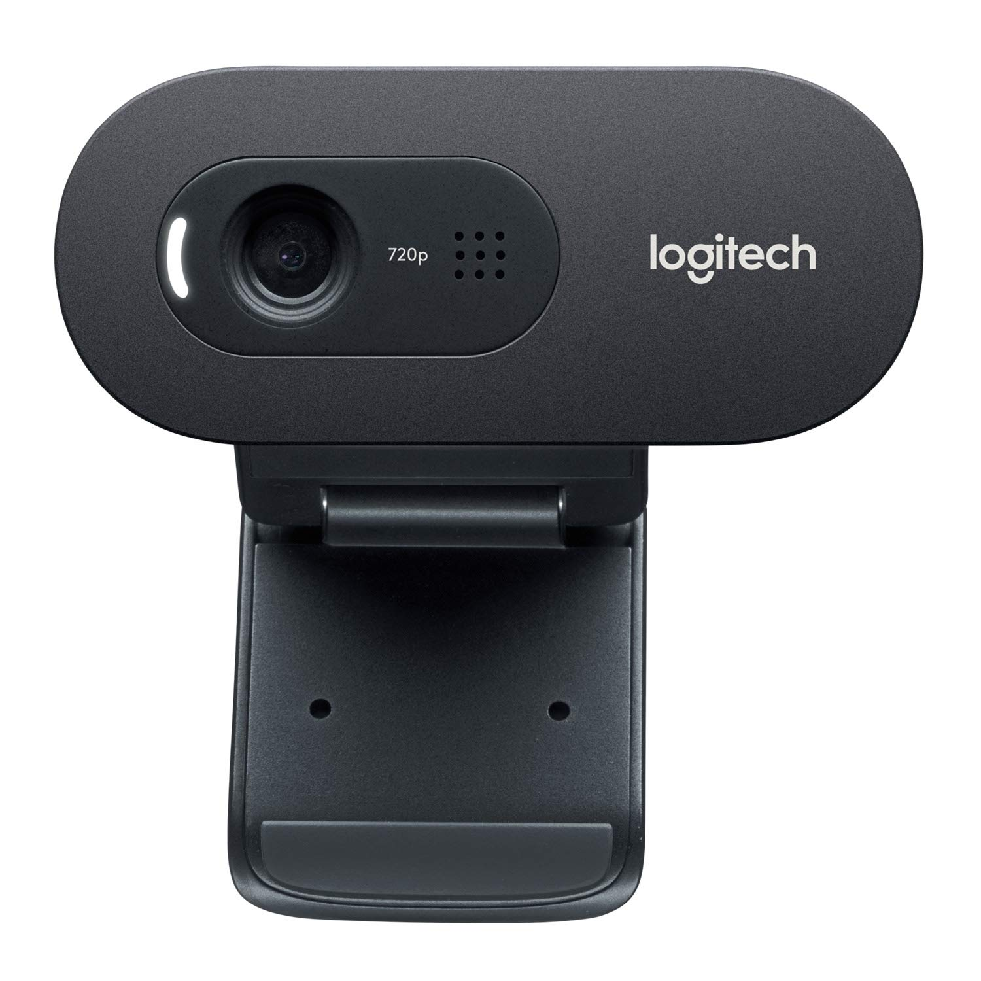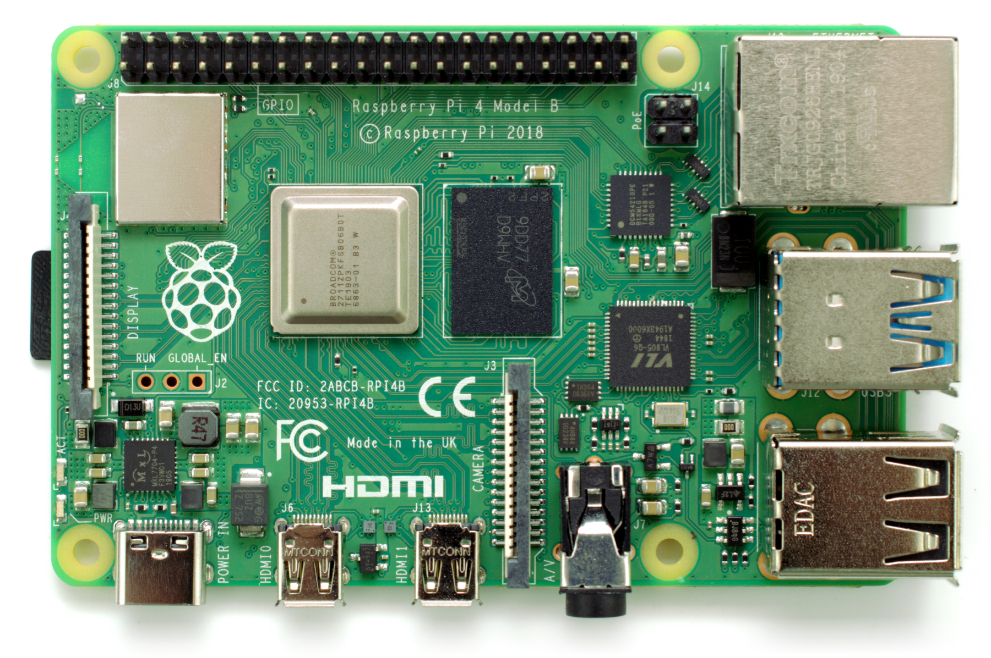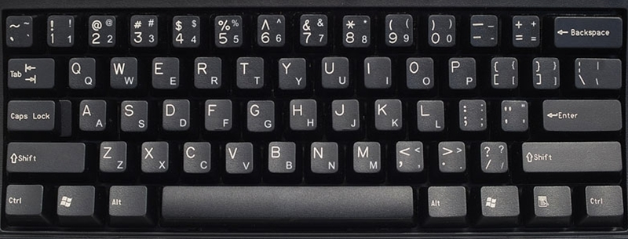

1. (2) (3)

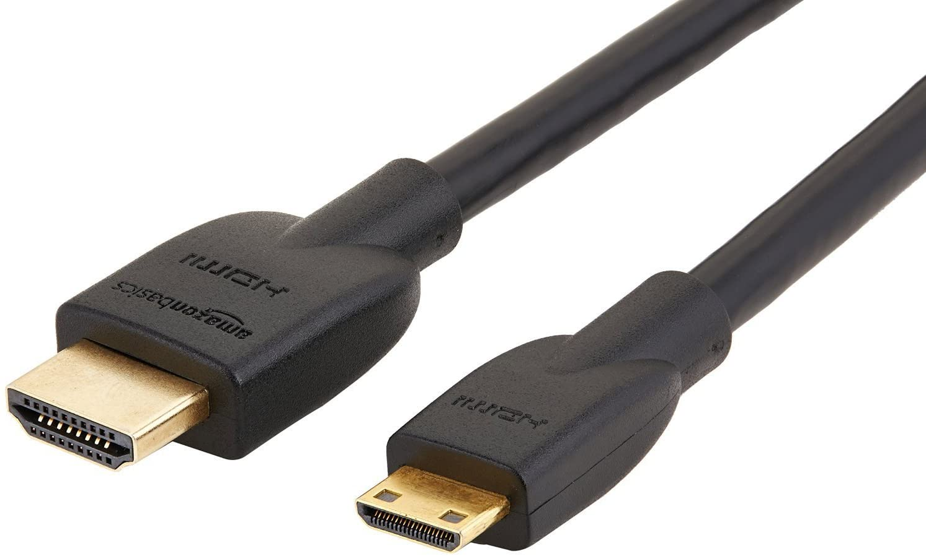 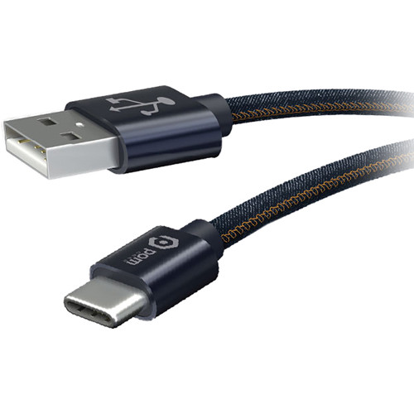 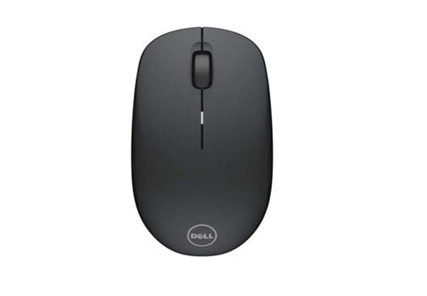

(4) (5) (6)

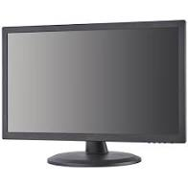 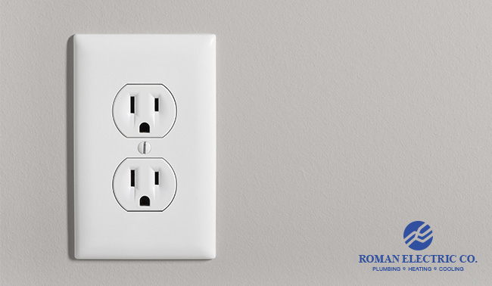 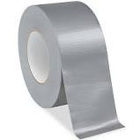

(7) (8) (9)

**Overview:**

The Oyster Activity Detection System determines the level of oyster activity in an aquatic tank. The following pages are a tutorial on how to work this system.

**Software Setup: Part 1**

Using duct tape, tape the tail of the Logitech camera to any one top of vertices of the tank. Adjust it so the camera is looking down at the oyster shells.

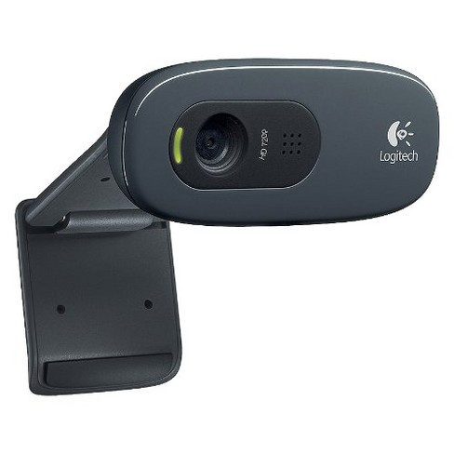 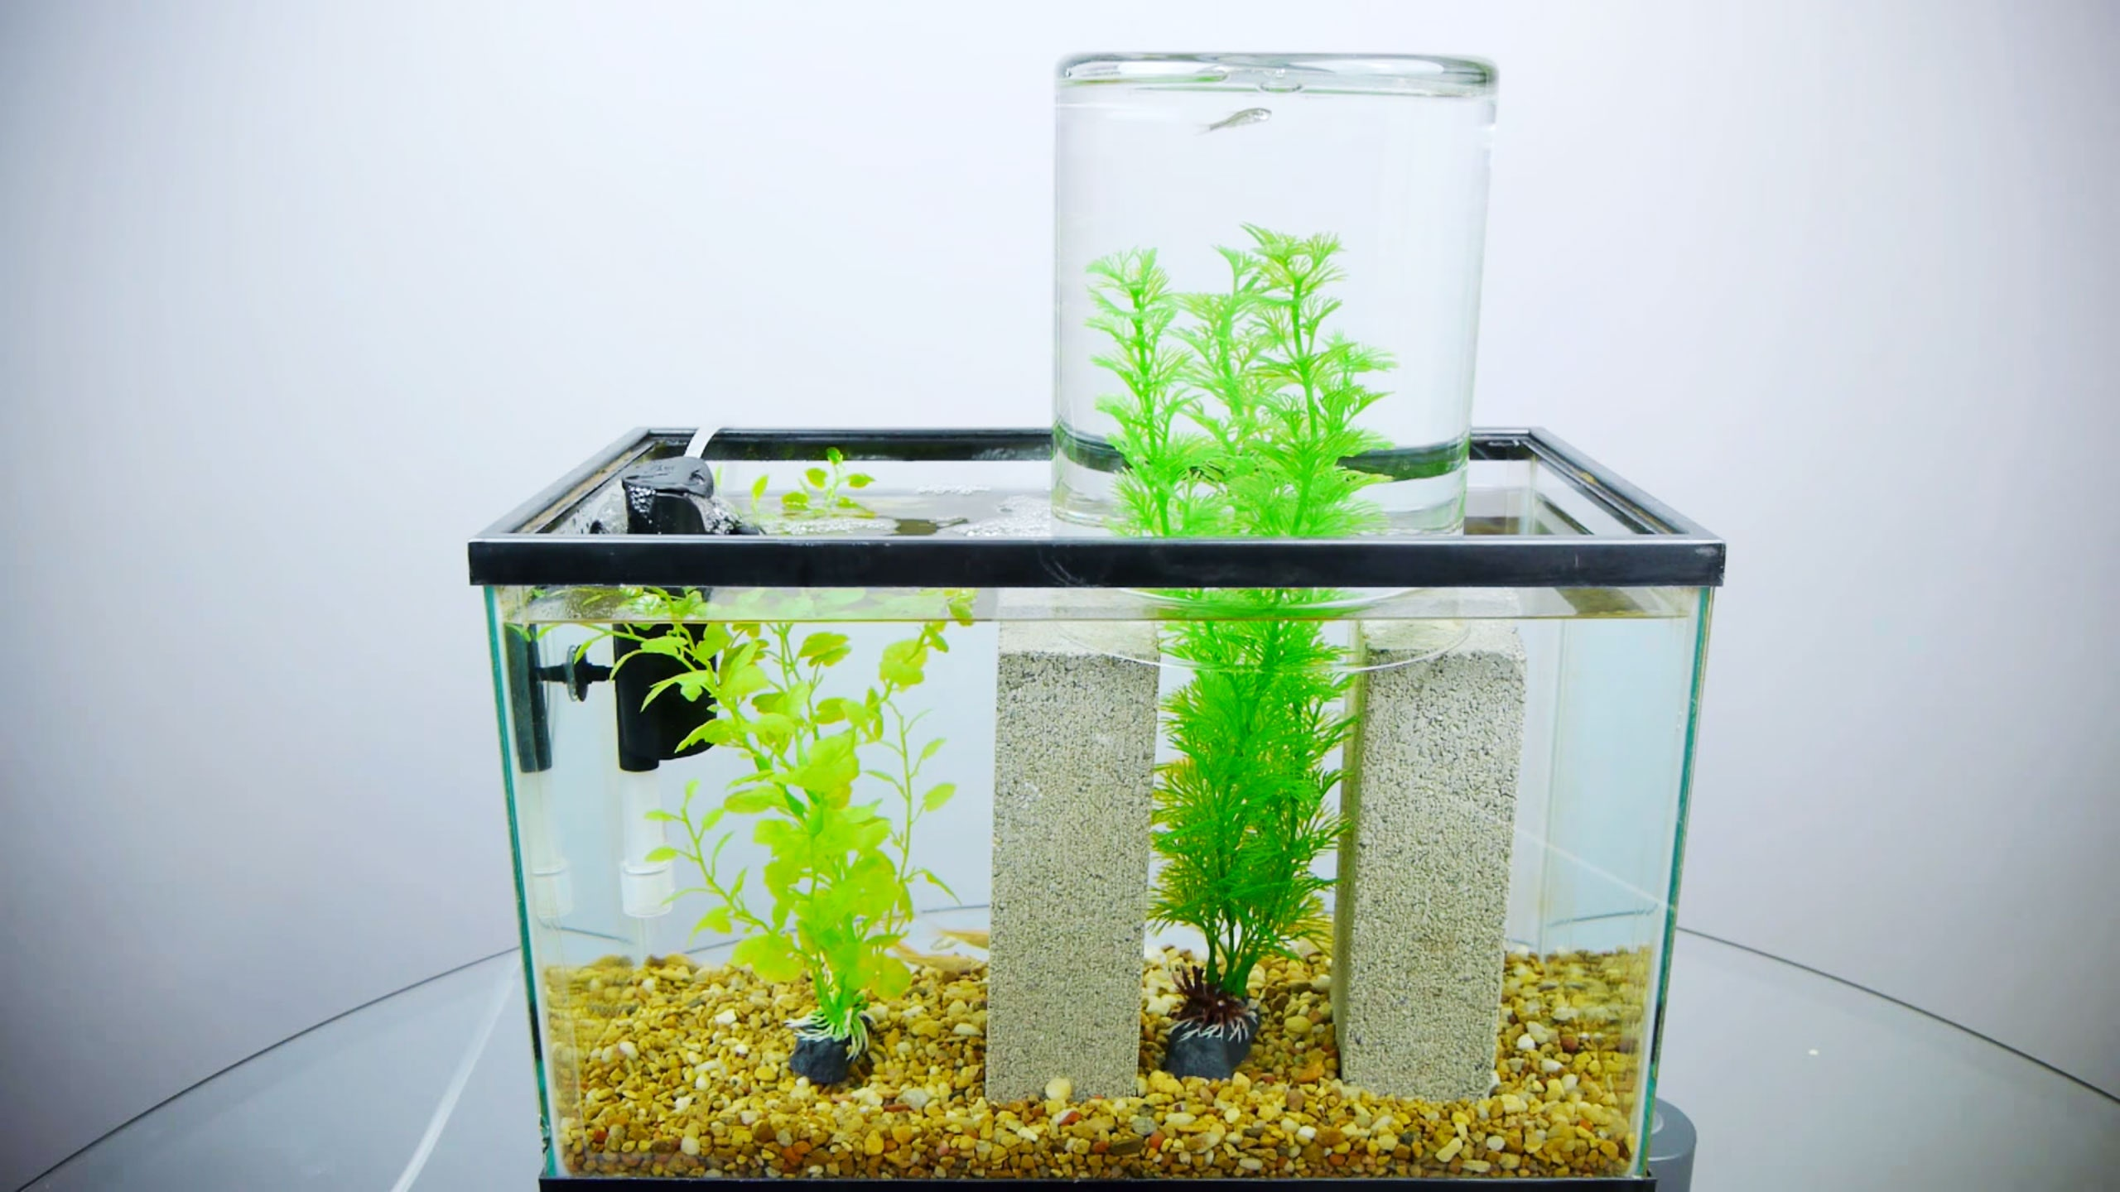

Tape the tail of camera here

**Software Setup: Part 2**

Plug the USB part for the camera into the raspberry pi. Also, plug one end of the USB-C cable into the raspberry pi port and the other end into the monitor port. Do the same with the keyboard and mouse. Also, plug in monitor power cord to outlet. Turn on monitor.

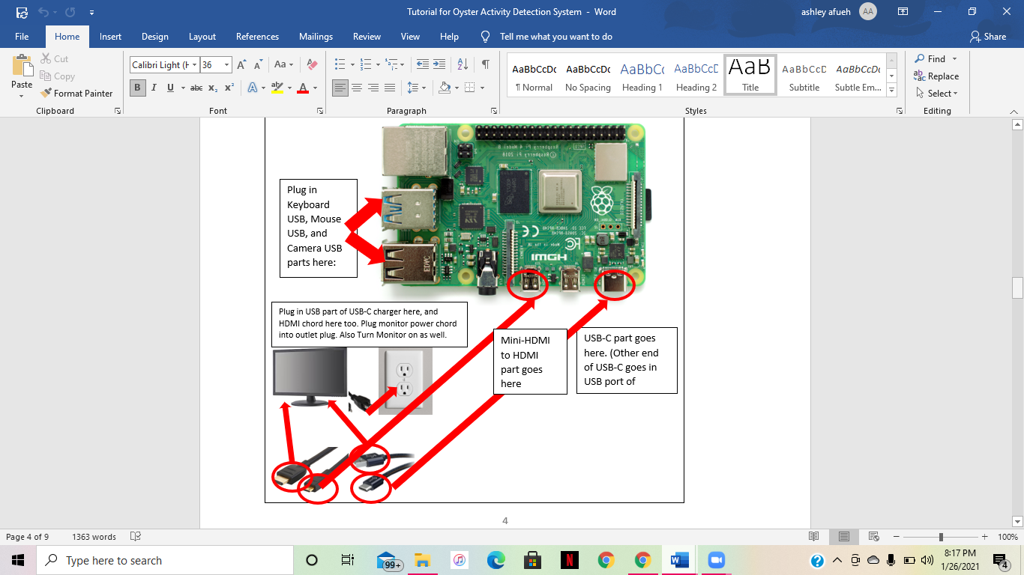

1

2

3

“DuckDuckGoo” should pop up here, click that

**Software Setup: Part 5:**

Now that your raspberry pi operating system is setup, you can now access the internet on the system. Go to the following link to setup the program via Jupyter notebook. When the link opens, at the top of the link, there will be a button called “Open with”. Click that button. Underneath that, click Google Collaboratory.

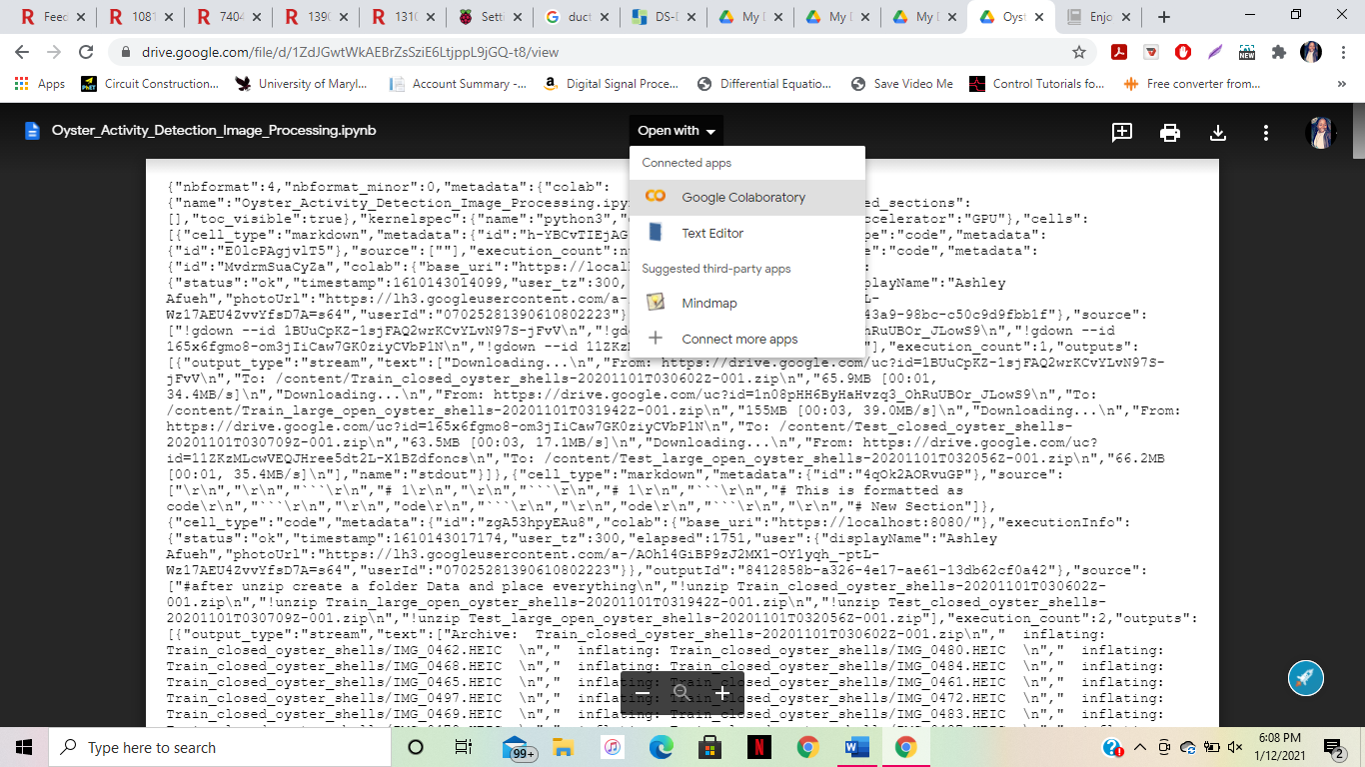

**Software Setup: Part 4:**

Now that your raspberry pi operating system is setup, you can now access the internet on the system. Click on the 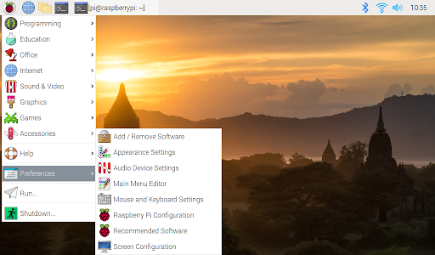 icon and then scroll over “internet”. From there another list of items should pop up. Click “duckduckgo” and then an internet browser will pop up.



**Software Setup: Part 3:**

Go to the following website to setup your raspberry pi operating system: <https://projects.raspberrypi.org/en/projects/raspberry-pi-setting-up>

Block 1

Block 5

Block 4

Block 2

Block 3

Brackets

Play Sign

**Software Setup: Part 6:**

When you clock Google Collaboratory, the following link should pop up:

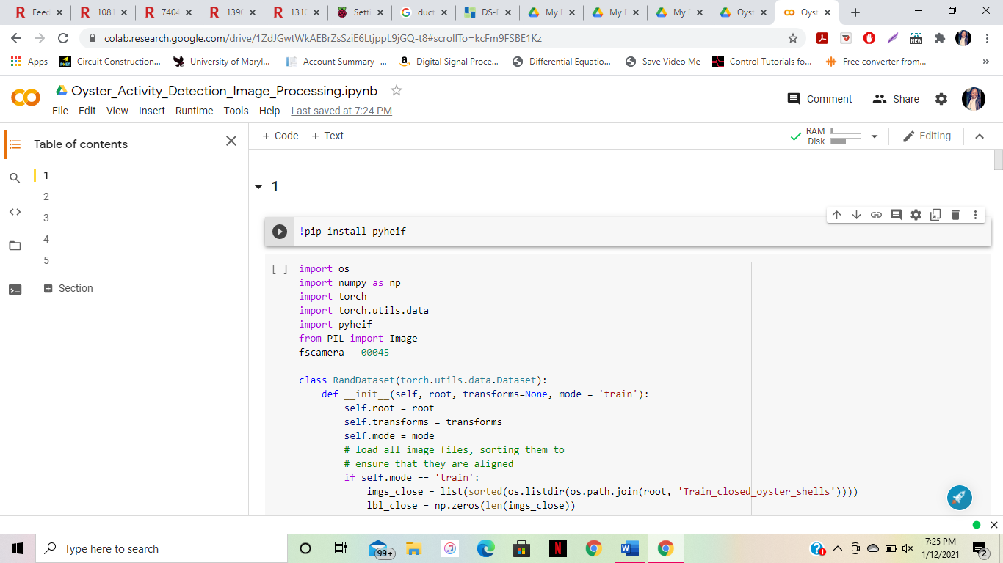 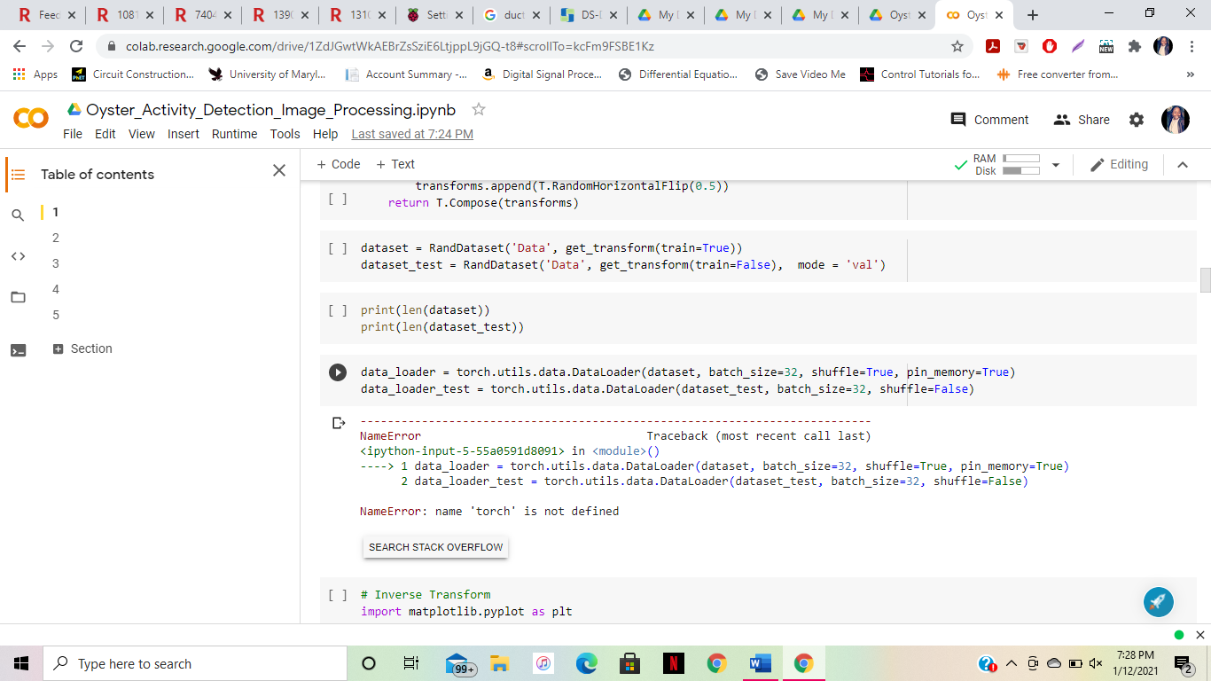

There are 21 different “blocks” of code, or squares that include code, highlighted in red.

At the top left of these blocks, there is a pair of brackets, highlighted in blue. The symbol for them like this: .

When you put your curser over the brackets, they become “play sign”. This sign looks like this:  . It is highlighted in green.

In order to begin running the system, click on all 21 of these “play” signs throughout the blocks of code. When you finish clicking all 21 of the “play” signs, the program will run.

The numerical and visual results of the program will be available on the following website: <https://aafueh.wixsite.com/oyster-aa-sn>

The frequency of the pictures being taken will be 1 minute automatically. The process of changing the frequency, turning off the system, and restarting the system can all be found below. Also, an in-depth explanation of how the website works can be found below.

**How to set Length of Time for Program Running**

Underneath the time that can be set for the frequency of the picture being taken, there is a line of code that says “fsduration – 00D 00H 00M 00S”.

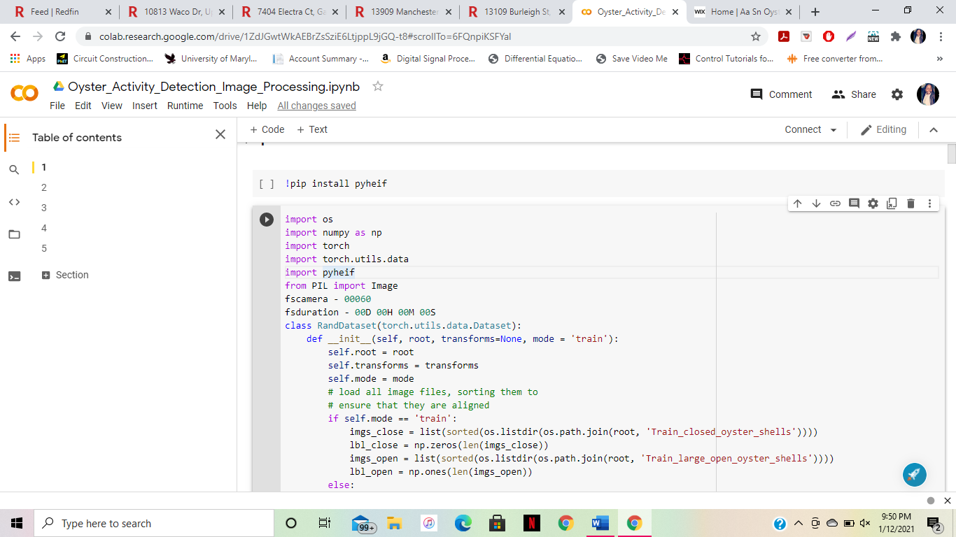

This sets the duration for how long the program runs. 00D starts for the days, 00H starts for the hours, 00M starts for the minutes, and 00S starts for the seconds. You can set the duration for how long you want the program to run, by setting the number of days, hours, minutes, and/or seconds corresponding to the format in the code.

**How to Change Frequency of Picture Being Taken**

The frequency is automatically set for 1 minute. If you want to change it, go to the 2nd block of code in the jupyper notebook, which starts with the following text:

import os

import numpy as np

import torch

In this block, look for the 7th line of code which says “fscamera – 00060”. The number 00060 means 60 seconds, which is equal to 1 minute. The frequency cannot be shorter than 1 minute, but can be longer than 1 minute. If you want to change this time for the frequency of when the picture is taken, then change the number of minutes to seconds. Take the seconds you desire and put it in the format of “00060”, which basically means a number with 5 digits. If the number of seconds you want to use has 3 digits, put 2 zeros before the first digit of the number. If the number of seconds you want to use has 2 digits, put 3 zeros before the first digit of the number. For example, if you wanted 2 minutes, since 2 minutes is equal to 120 seconds, you would put the number “00120”. If you wanted 1 minute and 30 seconds, since 1 minute and 30 seconds is equal to 90 seconds, you would put the number “00090”.



Stop Sign

Play Sign

**How to Reset Program (which erases data)**

To reset the program, first stop the program from running. Then, locate the last block of code at the bottom. It should look like this:

In this block of code, copy and paste the following code into it:

restart = input("\nDo you want to restart the program? [y/n] > ")

if str(restart) == str("y"):

os.execl(sys.executable, sys.executable, * sys.argv) # Nothing hapens

else:

print("\nThe program will be closed...")

sys.exit(0)

and paste

Then click “play” on the block of code, in the top left corner. After you clock play, the program will ask you a question stating “Do you want to restart the program?” By inputting the letter” y” or the letter “n”, you have an option of choosing yes or no, respectively. When you type “y” then click enter, the program will then type “The program will be closed…” and restart the program. All data in the archives, including numerical data, graph data, and pictures will be deleted. Also, the website will now currently display no data.

**How to Start or Stop Program from Running**

To start the program, in the Jupyter notebook, click all 21 “play” buttons in all the blocks of code.

When the code is running, the “play” button will become a “stop” button with a buffering sign circulating around it. It has this symbol: 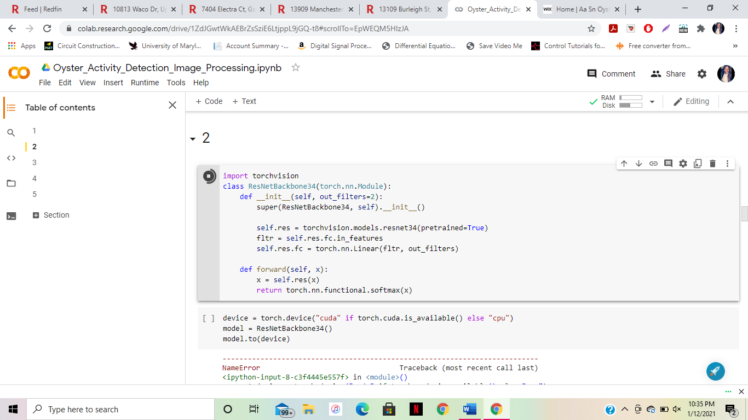. This symbol is also highlighted in yellow. To stop the program, in the Jupyter notebook, click all 21 “stop” buttons in all 21 blocks of code.



**How to Read Data on Website**

The link to the website can be found here: <https://aafueh.wixsite.com/oyster-aa-sn>

The website looks like this:

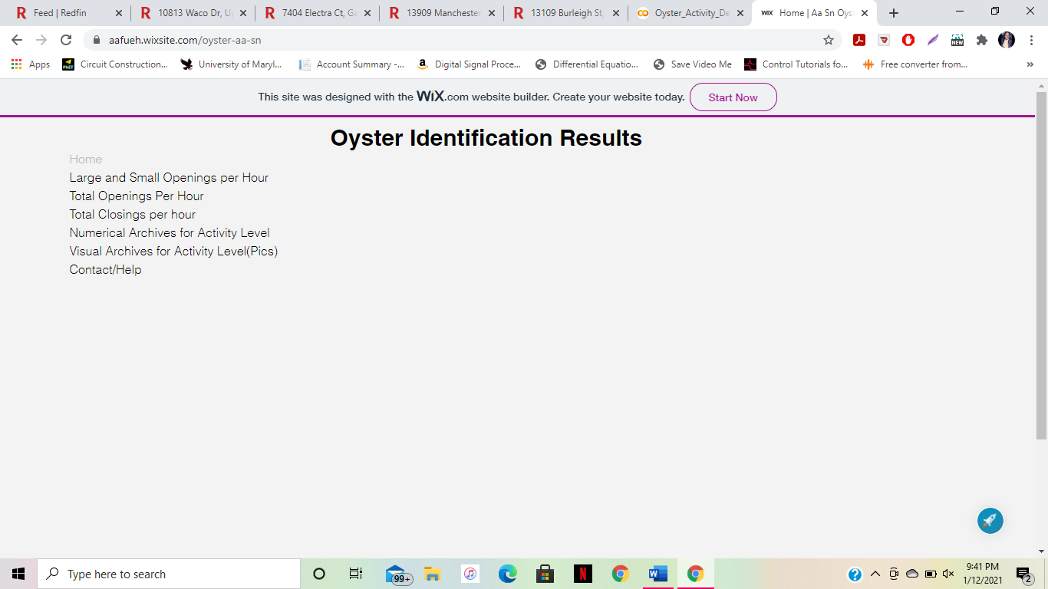

The 2nd – 4th tab is made up of bar graphs that display data for every hour on the hour, for as long as you started running the program. As more hours go by, a new graph starts for every new hour.

The second tab is to see the amount of large and small openings in 1 hour, on a bar graph. The third tab is to see the total amount of openings per hour, on a bar graph. The fourth tab is to see the total amount of closings per hour, on a bar graph. The fifth tab is to view the numerical archives for the data, which is shown in a spreadsheet. The 6th tab is to show the pictures of the data, which is to show the pictures of the labeled and identified pictures of the oysters.

### Source Code from Google Cloud Function

* package com.example;
* import com.google.cloud.functions.HttpFunction;
* import com.google.cloud.functions.HttpRequest;
* import com.google.cloud.functions.HttpResponse;
* import java.io.BufferedWriter;
* import chart.js;
* public class Example implements HttpFunction {
* @Override
* public void service(HttpRequest request, HttpResponse response) throws Exception {
* BufferedWriter writer = response.getWriter();
* <!-- begin snippet: js hide: false console: true babel: null -->
* <!-- language: lang-js -->
* function tableCreate() {
* //body reference
* var body = document.getElementsByTagName("body")[0];
* // create elements <table> and a <tbody>
* var tbl = document.createElement("table");
* var tblBody = document.createElement("tbody");
* // cells creation
* for (var j = 0; j <= 2; j++) {
* // table row creation
* var row = document.createElement("tr");
* for (var i = 0; i < 2; i++) {
* // create element <td> and text node
* //Make text node the contents of <td> element
* // put <td> at end of the table row
* var cell = document.createElement("td");
* var cellText = document.createTextNode("cell is row " + j + ", column " + i);
* cell.appendChild(cellText);
* row.appendChild(cell);
* }
* //row added to end of table body
* tblBody.appendChild(row);
* }
* // append the <tbody> inside the <table>
* tbl.appendChild(tblBody);
* // makes table variation of pink colors
* tbl.appearance(pinkvariation);
* // put <table> in the <body>
* body.appendChild(tbl);
* // tbl border attribute to
* tbl.setAttribute("border", "2");
* }
* <!-- language: lang-html -->
* <table width="100%" border="1">
* <tr>
* <td>&nbsp;</td>
* <td>&nbsp;</td>
* </tr>
* <tr>
* <td>&nbsp;</td>
* <td rowspan="2">&nbsp;</td>
* </tr>
* <tr>
* <td>&nbsp;</td>
* </tr>
* </table>
* <!-- end snippet -->
* // for the graph
* <!DOCTYPE html>
* <html>
* <head>
* <script src="https://cdnjs.cloudflare.com/ajax/libs/Chart.js/2.5.0/Chart.min.js"></script>
* </head>
* <body>
* // creates the bars
* <canvas id="bar-chart" width=300" height="150"></canvas>
* <script>
* //chart for large and small openings
* new Chart(document.getElementById("Hour 1"), {
* type: 'bar',
* data: {
* labels: ["1-10", "11-20", "21-30", "31-40", "41-50", "51-60"],
* datasets: [
* {
* label: "Large openings",
* backgroundColor: ["blue"],
* label: "Small openings",
* backgroundColor: ["green"],
* data: [insert ("graph-from-data")],
* }
* ]
* },
* options: {
* legend: { display: false },
* title: {
* display: true,
* text: 'Number of Developers in Every Continent'
* },
* scales: {
* yAxes: [{
* ticks: {
* beginAtZero:true
* }
* }]
* }
* }
* //chart for total closings
* new Chart(document.getElementById("Hour 1"), {
* type: 'bar',
* data: {
* labels: ["1-10", "11-20", "21-30", "31-40", "41-50", "51-60"],
* datasets: [
* {
* label: "Number of closings",
* backgroundColor: ["green"],
* data: [insert ("graph-from-data")],
* }
* ]
* },
* options: {
* legend: { display: false },
* title: {
* display: true,
* text: 'Number of Developers in Every Continent'
* },
* scales: {
* yAxes: [{
* ticks: {
* beginAtZero:true
* }
* }]
* }
* }
* });
* </script>

* //chart for total openings
* new Chart(document.getElementById("Hour 1"), {
* type: 'bar',
* data: {
* labels: ["1-10", "11-20", "21-30", "31-40", "41-50", "51-60"],
* datasets: [
* {
* label: "Number of openings",
* backgroundColor: ["green"],
* data: [insert ("graph-from-data")],
* }
* ]
* },
* options: {
* legend: { display: false },
* title: {
* display: true,
* text: 'Number of Developers in Every Continent'
* },
* scales: {
* yAxes: [{
* ticks: {
* beginAtZero:true
* }
* }]
* }
* }
* });
* </body>
* </html>
* }
* }

### 3. Source Code for Google Collab Function

### **1** #starts the process of taking the picture and starts the camera

!pip install pyheif

//this installs important packages

import os

import numpy as np

import torch

import torch.utils.data

import pyheif

from PIL import Image

#sets duration of program and frequency of camera being taken

fscamera - 00060

fsduration - 00D 00H 00M 00S

class RandDataset(torch.utils.data.Dataset):

def __init__(self, root, transforms=None, mode = 'train'):

self.root = root

self.transforms = transforms

self.mode = mode

# load all image files, sorting them to

# ensure that they are aligned

if self.mode == 'train':

imgs_close = list(sorted(os.listdir(os.path.join(root, 'Train_closed_oyster_shells'))))

lbl_close = np.zeros(len(imgs_close))

imgs_open = list(sorted(os.listdir(os.path.join(root, 'Train_large_open_oyster_shells'))))

lbl_open = np.ones(len(imgs_open))

else:

imgs_close = list(sorted(os.listdir(os.path.join(root, 'Test_closed_oyster_shells'))))

lbl_close = np.zeros(len(imgs_close))

imgs_open = list(sorted(os.listdir(os.path.join(root, 'Test_large_open_oyster_shells'))))

lbl_open = np.ones(len(imgs_open))

self.imgs = imgs_close + imgs_open

self.labels = np.concatenate((lbl_close, lbl_open))

def __len__(self):

return len(self.imgs)

def __getitem__(self, idx):

# load images ad masks

if self.mode == 'train':

if os.path.isfile(os.path.join(self.root, 'Train_closed_oyster_shells', self.imgs[idx])):

imgs_path = os.path.join(self.root, 'Train_closed_oyster_shells', self.imgs[idx])

if os.path.isfile(os.path.join(self.root, 'Train_large_open_oyster_shells', self.imgs[idx])):

imgs_path = os.path.join(self.root, 'Train_large_open_oyster_shells', self.imgs[idx])

else:

if os.path.isfile(os.path.join(self.root, 'Test_closed_oyster_shells', self.imgs[idx])):

imgs_path = os.path.join(self.root, 'Test_closed_oyster_shells', self.imgs[idx])

if os.path.isfile(os.path.join(self.root, 'Test_large_open_oyster_shells', self.imgs[idx])):

imgs_path = os.path.join(self.root, 'Test_large_open_oyster_shells', self.imgs[idx])

heif_file = pyheif.read(imgs_path)

img = Image.frombytes(

heif_file.mode,

heif_file.size,

heif_file.data,

"raw",

heif_file.mode,

heif_file.stride,

)

if self.transforms is not None:

img = self.transforms(img)

lbl = self.labels[idx]

return img, torch.tensor(lbl, dtype=torch.long)

#Data Transform – transforms data into readable image

import torchvision.transforms as T

def get_transform(train):

transforms = []

# converts the image, a PIL image, into a PyTorch Tensor

transforms.append(T.Resize((224,224)))

transforms.append(T.ToTensor())

transforms.append(T.Normalize([0.485, 0.456, 0.406], [0.229, 0.224, 0.225]))

if train:

# during training, randomly flip the training images

# and ground-truth for data augmentation

transforms.append(T.RandomHorizontalFlip(0.5))

return T.Compose(transforms)

dataset = RandDataset('Data', get_transform(train=True))

dataset_test = RandDataset('Data', get_transform(train=False), mode = 'val')

print(len(dataset))

print(len(dataset_test))

data_loader = torch.utils.data.DataLoader(dataset, batch_size=32, shuffle=True, pin_memory=True)

data_loader_test = torch.utils.data.DataLoader(dataset_test, batch_size=32, shuffle=False)

# Inverse Transform

import matplotlib.pyplot as plt

inv_normalize = T.Normalize(

mean=[-0.485/0.229, -0.456/0.224, -0.406/0.225],

std=[1/0.229, 1/0.224, 1/0.255]

)

def imshow(img):

img = inv_normalize(img) # unnormalize

npimg = img.numpy()

plt.imshow(np.transpose(npimg, (1, 2, 0)))

plt.show()

# Visualise Data Loader

import torchvision

imag, labl = next(iter(data_loader_test))

imshow(torchvision.utils.make_grid(imag))

print(labl)

# 2

import torchvision

class ResNetBackbone34(torch.nn.Module):

def __init__(self, out_filters=2):

super(ResNetBackbone34, self).__init__()

self.res = torchvision.models.resnet34(pretrained=True)

fltr = self.res.fc.in_features

self.res.fc = torch.nn.Linear(fltr, out_filters)

def forward(self, x):

x = self.res(x)

return torch.nn.functional.softmax(x)

device = torch.device("cuda" if torch.cuda.is_available() else "cpu")

model = ResNetBackbone34()

model.to(device)

# 3

# Define the training parameters and function for optimise the parameters

epochs = 30

max_lr = 0.01

grad_clip = 0.1

weight_decay = 1e-4

val_acc = 0

loss_fn = torch.nn.CrossEntropyLoss()

optimizer = torch.optim.Adam(model.parameters(), max_lr, weight_decay=weight_decay)

sched = torch.optim.lr_scheduler.OneCycleLR(optimizer, max_lr, epochs=epochs,

steps_per_epoch=len(data_loader))

# Load and save the checkpoints

def save_checkpoint(save_path, model, val_loss, val_acc, start_epoch):

if save_path == None:

return

state_dict = {'model_state_dict': model.state_dict(),

'val_loss': val_loss,

'val_acc' : val_acc,

'start_epoch' : start_epoch}

torch.save(state_dict, save_path)

print(f'Model saved to ==> {save_path}')

def load_checkpoint(load_path, model, device='cpu'):

if load_path==None:fswebcam -r 720x1280 3.jpg

return

state_dict = torch.load(load_path, map_location=device)

print(f'Model loaded from <== {load_path}')

model.load_state_dict(state_dict['model_state_dict'])

epoch = state_dict['start_epoch']

return epoch

# Training and Evaluaton

for epoch in range(epochs):

model.train()

train_losses = 0

i = 1

for batch in data_loader:

print('{}/{} starting...'.format(i, len(data_loader)))

i += 1

img = batch[0].to(device)

label = batch[1].to(device)

optimizer.zero_grad()

pred = model(img)

loss = loss_fn(pred, label)

loss.backward()

#torch.nn.utils.clip_grad_value_(model.parameters(), grad_clip)

optimizer.step()

sched.step()

train_losses += loss.item()

with torch.no_grad():

correct = 0

total = 0

model.eval()

val_loss = 0

for batch in data_loader_test:

img = batch[0].to(device)

label = batch[1].to(device)

pred = model(img)

_, predicted = torch.max(pred.data, 1)

total += label.size(0)

correct += (predicted == label).sum().item()

loss = loss_fn(pred, label)

val_loss += loss.item()

acc = 100 * (correct/total)

val_loss = val_loss/len(data_loader_test)

if acc>val_acc:

save_checkpoint('weights_andr/epoch_'+str(epoch+1), model, val_loss, acc, epoch)

val_acc = acc

print('Epoch {}/{}, train_loss {}, valid_loss {}, valid_acc {}'.format(epoch+1, epochs, train_losses/len(data_loader), val_loss, acc))

# 4

model = ResNetBackbone34()

load_checkpoint('/content/epoch_11', model)

model.to(device)

correct = 0

total = 0

#test_loader = torch.utils.data.DataLoader(dataset, batch_size=1, shuffle=False, pin_memory=True)

with torch.no_grad():

model.eval()

for batch in data_loader_test:

img = batch[0].to(device)

label = batch[1].to(device)

pred = model(img)

_, predicted = torch.max(pred.data, 1)

print(predicted, label)

total += label.size(0)

correct += (predicted == label).sum().item()

print('accuracy is ', correct/total)

!cp '/content/weights_andr/epoch_11' -r '/content/drive/My Drive/work/weights_andr'

# 5

#sends info to dropbox

#https://dropbox.com/file/d/1zSm6cOwzhA4llN2cRZ63HJ6om4h34eD8/view?usp=sharing

!gdown --id 1zSm6cOwzhA4llN2cRZ63HJ6om4h34eD8

# Load the trained model

model = ResNetBackbone34()

state_dict = torch.load("/content/epoch_11", torch.device("cpu"))

model.load_state_dict(state_dict['model_state_dict'])

from google.colab import files

uploaded = files.upload()

file_names, _ = list(uploaded.items())[0]

#Test just update the file_names

from PIL import Image

import pyheif

file_names = '/content/Data/Test_closed_oyster_shells/IMG_0685.HEIC'

heif_file = pyheif.read(file_names)

image = Image.frombytes(

heif_file.mode,

heif_file.size,

heif_file.data,

"raw",

heif_file.mode,

heif_file.stride,

)

trans_fn = get_transform(train=False)

test_image = trans_fn(image)

test_image = test_image.unsqueeze(dim=0)

pred = model(test_image.to(device))

_, predicted = torch.max(pred.data, 1)

predicted

classes = ['Close', 'Open']

print('Predicted class is ',classes[predicted.item()])

|  |
| --- |
| #adds arguments & layers to the project  ap = argparse.ArgumentParser() |
|  | ap.add_argument('-i', '--image', required=True, |
|  | help = 'path to input image') |
|  | ap.add_argument('-c', '--config', required=True, |
|  | help = 'path to yolo config file') |
|  | ap.add_argument('-w', '--weights', required=True, |
|  | help = 'path to yolo pre-trained weights') |
|  | ap.add_argument('-cl', '--classes', required=True, |
|  | help = 'path to text file containing class names') |
|  | args = ap.parse_args() |
|  | #gives output layers |
|  |  |
|  | def get_output_layers(net): |
|  |  |
|  | layer_names = net.getLayerNames() |
|  |  |
|  | output_layers = [layer_names[i[0] - 1] for i in net.getUnconnectedOutLayers()] |
|  |  |
|  | return output_layers |
|  | #labels predictions, gives color for rectangle, gives font, etc, gives width, height, and scale for label and rectangle |
|  |  |
|  | def draw_prediction(img, class_id, confidence, x, y, x_plus_w, y_plus_h): |
|  |  |
|  | label = str(classes[class_id]) |
|  |  |
|  | color = COLORS[green] |
|  |  |
|  | cv2.rectangle(img, (x,y), (x_plus_w,y_plus_h), color, 2) |
|  |  |
|  | cv2.putText(img, label, (x-10,y-10), cv2.FONT_HERSHEY_SIMPLEX, 0.5, color, 2) |
|  |  |
|  |  |
|  | image = cv2.imread(args.image) |
|  |  |
|  | Width = image.shape[1] |
|  | Height = image.shape[0] |
|  | scale = 0.00392 |
|  |  |
|  | #gives categories of different classes  classes = None |
|  |  |
|  | with open(args.classes, 'r') as f: |
|  | classes = [line.strip() for line in f.readlines()] |
|  |  |
|  | COLORS = np.random.uniform(0, 255, size=(len(classes), 3)) |
|  |  |
|  | net = cv2.dnn.readNet(args.weights, args.config) |
|  |  |
|  | blob = cv2.dnn.blobFromImage(image, scale, (416,416), (0,0,0), True, crop=False) |
|  |  |
|  | net.setInput(blob) |
|  |  |
|  | outs = net.forward(get_output_layers(net)) |
|  |  |
|  | class_ids = [] |
|  | confidences = [] |
|  | boxes = [] |
|  | conf_threshold = 0.5 |
|  | nms_threshold = 0.4 |
|  |  |
|  |  |
|  | for out in outs: |
|  | for detection in out: |
|  | scores = detection[5:] |
|  | class_id = np.argmax(scores) |
|  | confidence = scores[class_id] |
|  | if confidence > 0.5: |
|  | center_x = int(detection[0] * Width) |
|  | center_y = int(detection[1] * Height) |
|  | w = int(detection[2] * Width) |
|  | h = int(detection[3] * Height) |
|  | x = center_x - w / 2 |
|  | y = center_y - h / 2 |
|  | class_ids.append(class_id) |
|  | confidences.append(float(confidence)) |
|  | boxes.append([x, y, w, h]) |
|  |  |
|  |  |
|  | indices = cv2.dnn.NMSBoxes(boxes, confidences, conf_threshold, nms_threshold) |
|  |  |
|  | for i in indices: |
|  | i = i[0] |
|  | box = boxes[i] |
|  | x = box[0] |
|  | y = box[1] |
|  | w = box[2] |
|  | h = box[3] |
|  | draw_prediction(image, class_ids[i], confidences[i], round(x), round(y), round(x+w), round(y+h)) |
|  | #labels image |
|  | cv2.imshow("name", image) |
|  | cv2.waitKey() |
|  |  |
|  | cv2.imwrite("name.jpg", image) |
|  | cv2.destroyAllWindows() |

## REFERENCES

(Clam Biology, 2013) (wikiHOW Reference , 2020) (Pandora, 2019) (Staff-Member, 2015) (FRESHWATER CLAMS: CARE, FOOD, & SIZE – VIDEO, n.d.) (Dave, 2012) (Train, 2015) (Rodriguez, Rico, Rabuñal, & Agudo, 2015) (Jones, 2017) (Chaoyu, 2016) (Fulton III, 2019) (How to Send Data to ThingSpeak Cloud using Raspberry Pi, 2019) (Rosebrock, 2018) (SRIVASTAVA, 2019) (Image classification, 2021) (Python | Image Classification using keras, 2020) (Learn about Convolutional Neural Networks (CNN) from Scratch, 2020) (Ognjanovski, 2019) (PAI, 2020) (Lee, 2020) (Wang, 2018) (Garbade, 2018) (Moses, 2021)

# References (Extended)

* 1. Chaoyu. (2016). *Data Collection With Raspberry Pi*. Retrieved from Indestructible Circuits.

*Clam Biology*. (2013, May 14). Retrieved from Fisheries and Oceans Canada: https://www.pac.dfo-mpo.gc.ca/fm-gp/commercial/shellfish-mollusques/clam-palourde/bio-eng.html

2) Dave, S. (Director). (2012). *Image Processing tutorial part 1: Basic object tracking tutorial by Student dave* [Motion Picture].

3) *FRESHWATER CLAMS: CARE, FOOD, & SIZE – VIDEO*. (n.d.). Retrieved from Aquarium Care Basics - Freshwater Tanks: https://www.aquariumcarebasics.com/freshwater-clams/

4) Fulton III, S. (2019, May 20). *What Google Cloud Platform is and why you’d use it*. Retrieved from ZDNet: https://www.zdnet.com/article/what-google-cloud-platform-is-and-why-youd-use-it/

5) Garbade, M. J. (2018, September 6). *3 top open source JavaScript chart libraries*. Retrieved from Open Source: https://opensource.com/article/18/9/open-source-javascript-chart-libraries

*6) How to Send Data to ThingSpeak Cloud using Raspberry Pi*. (2019, January 18). Retrieved from IoTDesign: https://iotdesignpro.com/projects/how-to-send-data-to-thingspeak-cloud-using-raspberry-pi

7) *Image classification*. (2021, February 3). Retrieved from TensorFlow: https://www.tensorflow.org/tutorials/images/classification

7) Jones, D. (2017, September 9). *Sending pictures/images to remote database*. Retrieved from Stack Exchange: https://raspberrypi.stackexchange.com/questions/72301/sending-pictures-images-to-remote-database

8*) Learn about Convolutional Neural Networks (CNN) from Scratch*. (2020, January 15). Retrieved from analyticsvidhya: https://courses.analyticsvidhya.com/courses/convolutional-neural-networks-cnn-from-scratch?utm_source=blog&utm_medium=learn-image-classification-cnn-convolutional-neural-networks-3-datasets

9) Lee, S. (2020, August 16). *How to train neural networks for image classification — Part 1*. Retrieved from Medium: https://medium.com/nerd-for-tech/how-to-train-neural-networks-for-image-classification-part-1-21327fe1cc1

10) Moses, O. (2021, January 5). *ImageAIDocumentation*. Retrieved from GitHub: https://github.com/OlafenwaMoses/ImageAIDocumentation/blob/master/detection/index.rst

11) Ognjanovski, G. (2019, January 14). *Everything you need to know about Neural Networks and Backpropagation — Machine Learning Easy and Fun*. Retrieved from Towards Data Science : https://towardsdatascience.com/everything-you-need-to-know-about-neural-networks-and-backpropagation-machine-learning-made-easy-e5285bc2be3a#:~:text=The%20Neural%20Network%20is,the%20result%20for%20given%20inputs.

12) PAI, A. (2020, February 17). *CNN vs. RNN vs. ANN – Analyzing 3 Types of Neural Networks in Deep Learning*. Retrieved from Analytics Vidhya: https://www.analyticsvidhya.com/blog/2020/02/cnn-vs-rnn-vs-mlp-analyzing-3-types-of-neural-networks-in-deep-learning/

13) Pandora, I. (2019, August 5). *How to Keep and Care for Freshwater Clams in Aquariums*. Retrieved from PETHELPFUL: https://pethelpful.com/fish-aquariums/Introduction-Keeping-Clams-In-Aquariums

*Python | Image Classification using keras*. (2020, April 24). Retrieved from GEEKSFORGEEKS: https://www.geeksforgeeks.org/python-image-classification-using-keras/

14) Rodriguez, A., Rico, A., Rabuñal, J. R., & Agudo, J. P. (2015, June). *Fish Monitoring and Sizing Using Computer Vision*. Retrieved from Research Gate: https://www.researchgate.net/publication/277871043_Fish_Monitoring_and_Sizing_Using_Computer_Vision

15) Rosebrock, A. (2018, April 9). *How to (quickly) build a deep learning image dataset*. Retrieved from pyimagesearch: https://www.pyimagesearch.com/2018/04/09/how-to-quickly-build-a-deep-learning-image-dataset/

16) SRIVASTAVA, T. (2019, December 30). *Basics of Image Processing in Python*. Retrieved from analyticsvidhya: https://www.analyticsvidhya.com/blog/2014/12/image-processing-python-basics/

17) Staff-Member. (2015, May 1). *Hook, Line, & Sinker - Ocean Facts - How Do Clams Get Their Shells* . Retrieved from App: https://www.app.com/story/sports/outdoors/fishing/hook-line-and-sinker/2015/04/30/clams-shells-formed-grow/26660869/

18) Train, C. (Director). (2015). *10.1: Intro to Images - Processing Tutorial* [Motion Picture].

19) Wang, C.-F. (2018, July 15). *A Newbie’s Introduction to Convolutional Neural Networks*. Retrieved from Towards Data Science: https://towardsdatascience.com/what-is-a-neural-network-6010edabde2b#:~:text=Neural%20networks%20have%20a%20set,with%2064%20x%2064%20pixels.

20) wikiHOW Reference . (2020, February 20 ). *How to Take Care of a Live Clam*. Retrieved from wikihow.com: https://www.wikihow.com/Take-Care-of-a-Live-Clam